



 S.K.P ENGINEERING COLLEGE

Approved by AICTE & Affiliated to Anna University

NH 66, Somasipadi Post,Chinnakangiyanur, Tiruvannamalai,

Tamil Nadu-606611

**DEPARTMENT OF COMPUTER SCIENCE AND**

**ENGINEERING**

BACHELOR OF ENGINEERING 2024-2025

FIFTH SEMESTER

**PROJECT TITLE: CRM APPLICATION TO MANAGE THE MALL**

**Project Created by:** Prasanth.V, Praveen kumar.K, Ramesh Kumar.R, Ram kumar M

**Project Reviewed by:** Mr.Nasrudeen sha (AP/CSE)

**College Code:** 5122

**Team ID** : NM2024TMID09184





 S.K.P ENGINEERING COLLEGE

Approved by AICTE & Affiliated to Anna University

**DEPARTMENT OF COMPUTER SCIENCE AND**

**ENGINEERING**

Certified that this is a bonafide record of work done by

Name :

University Reg No :

Year / Semester : 3 / 5

Branch : CSE

Year : 2024-2025

**Staff-in-Charge Head of the Department**

Submitted for the

Practical Examination held on

**Internal Examiner External Examiner**

**A CRM Application to Manage the Mall**

**Project Description:**

“A CRM application to manage the mall” project involves developing a comprehensive CRM application on Salesforce for managing and streamlining operations within a shopping mall. The primary objective is to centralize customer and tenant data, optimize communication, improve tenant relationships, enhance customer satisfaction, and ultimately drive revenue growth for the mall. The CRM will offer robust features to manage tenant interactions, track mall activities, analyse customer behaviours, and provide actionable insights for mall management.

**Short Description:**

“A CRM application to manage the mall” is a project to build a Salesforce-based solution that centralizes customer and tenant data, streamlines mall operations, and enhances tenant and customer relationships.

**Technical Architecture:**

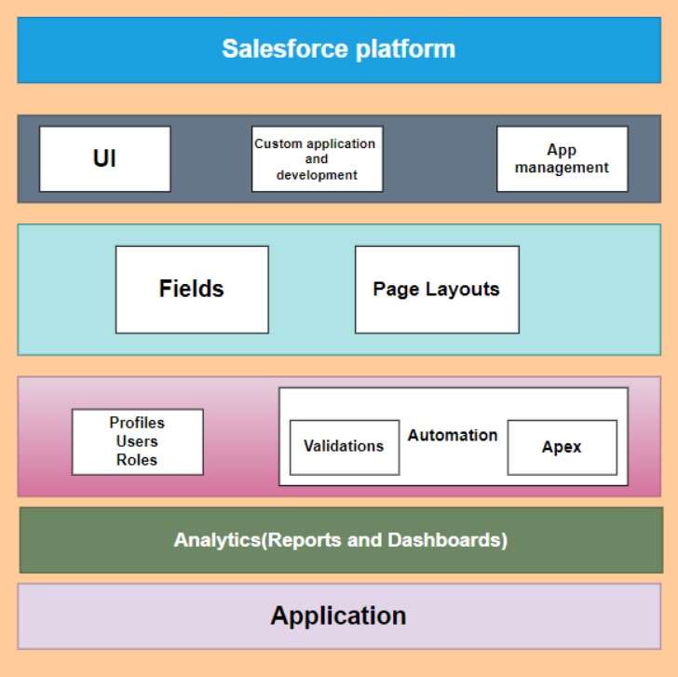

**Project Flow:**

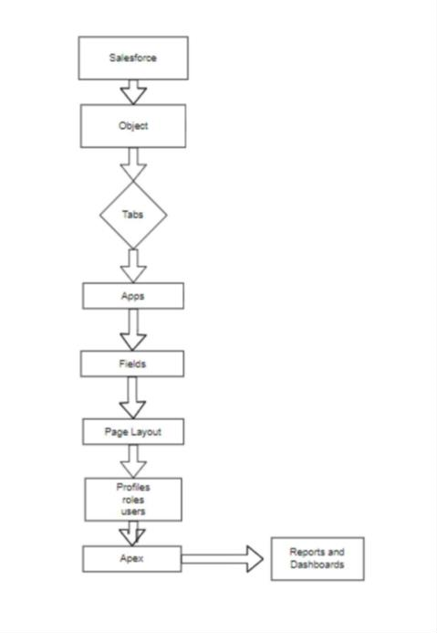

**System Requirements:**

* Windows 8 machine
* Install with two web browsers
* Bandwidth of 30mbps

**What you'll learn**

* 1. Real-Time Salesforce Project
  2. Data Modelling
  3. Creating an application
  4. User Interface Customization
  5. Importing bulk amounts of data
  6. Security in Salesforce
  7. Group Collaboration
  8. Reports & Dashboards **Use Case:**

The CRM application for mall management on Salesforce serves as a centralized platform to streamline tenant and customer interactions. Maintaining detailed tenant profiles and lease records, simplifies lease renewals, payment tracking, and performance assessments. Mall managers can monitor store sales data, helping to analyse trends and optimize tenant placement and promotions. The system also enhances customer engagement, supporting targeted marketing based on customer preferences and visit history. Event and campaign management tools allow tenants to collaborate on mall-wide promotions, increasing customer footfall and loyalty. Additionally, customer feedback and issue resolution features ensure timely responses, improving customer satisfaction. Real-time analytics and dashboards give mall administrators insights into operational KPIs, supporting datadriven decision-making. With robust security and data protection, the CRM system enables secure, efficient, and insightful mall management for both tenants and administrators.

# Milestone 1-Salesforce

**Introduction:**

Are you new to Salesforce? Not sure exactly what it is, or how to use it? Don’t know where you should start on your learning journey? If you’ve answered yes to any of these questions, then you’re in the right place. This module is for you.

Welcome to Salesforce! Salesforce is a game-changing technology, with a host of productivity-boosting features, that will help you sell smarter and faster. As you work toward your badge for this module, will take you through these features and answer the question, What is Salesforce, anyway?

**What Is Salesforce?**

Salesforce is your customer success platform, designed to help you sell, service, market, analyse, and connect with your customers.

Salesforce has everything you need to run your business from anywhere. Using standard products and features, you can manage relationships with prospects and customers, collaborate and engage with employees and partners, and store your data securely in the cloud.

So what does that mean? Well, before Salesforce, your contacts, emails, follow-up tasks, and prospective deals might have been organized something like this:

<https://youtu.be/r9EX3lGde5k>

**Use Case:**

Creating a Salesforce Developer Edition org allows developers to experiment, innovate, and build customized solutions within a controlled environment. With access to Salesforce's powerful development tools and features, developers can prototype, test, and refine their applications, empowering them to deliver robust and tailored solutions to meet unique business requirements. As a Salesforce Administrator for TheSmartBridge, you must have a Salesforce developer edition org in order to do all the required works which the CEO desires for TheSmartBridge.

Before creating our developer account, we must know what are the types of Editions Salesforce offers.

**Types of Salesforce Editions:**

|  |  |  |
| --- | --- | --- |
| 1 | Essentials | Designed for small businesses getting started with CRM to boost sales or service productivity. It includes a setup assistant and administration tools to customize your deployment as you grow. |
| 2 | Professional | Designed for businesses requiring full-featured CRM functionality. It includes straightforward and easy-to-use customization, integration, and administration tools to facilitate any small to midsize deployment. |
| 3 | Enterprise | Meets the needs of large and complex businesses. It gives you advanced customization and administration tools, in addition to all the functionality available in Professional Edition, that can support largescale deployments. Enterprise Edition also includes access to  Salesforce APIs, so you can easily integrate with back-office systems. |
| 4 | Unlimited | Maximizes your success and extends it across the entire enterprise through the Lightning Platform. It gives you new levels of platform flexibility for managing and sharing all your information on demand. Includes all Enterprise Edition functionality, Premier Support, full mobile access, unlimited custom apps, increased storage limits, and other features. |
| 5 | Developer | Provides access to the Lightning Platform and APIs. It lets developers extend Salesforce, integrate with other applications, and develop new tools and applications. Developer Edition also provides access to many of the features available in Enterprise Edition |

Let’s begin with creating our Salesforce Developer Account.

**Activity 1: Creating a Developer Account**

Creating a developer org in Salesforce.

1. Go to <https://developer.salesforce.com/signup>
2. On the signup form, enter the following details:

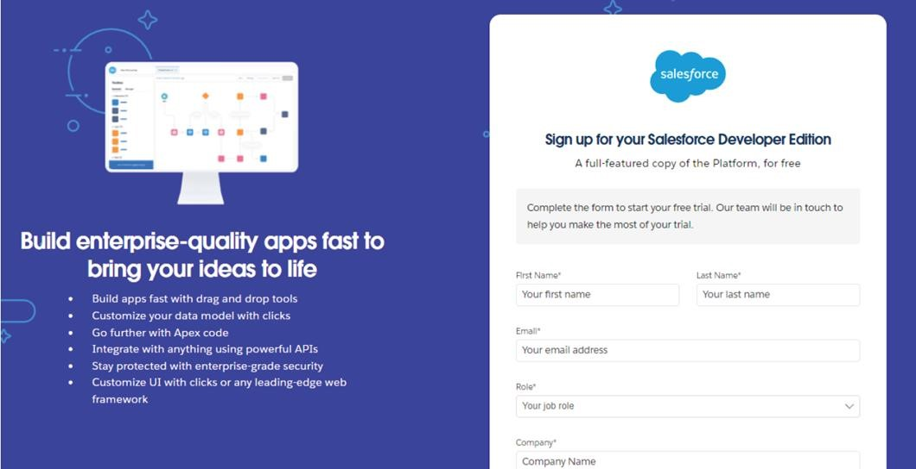

1. First name & Last name
2. Email
3. Role: Developer
4. Company: College Name
5. County: India
6. Postal Code: pin code
7. Username: should be a combination of your name and company This need not be an actual email ID, you can give anything in the format:

username@organization.com

Click on Sign me up after filling these.

**Activity 2: Account Activation**

1. Go to the inbox of the email that you used while signing up. Click on the verify account to activate your account. The email may take 5-10mins.
2. Click on Verify Account
3. Give a password answer a security question and click on change password.

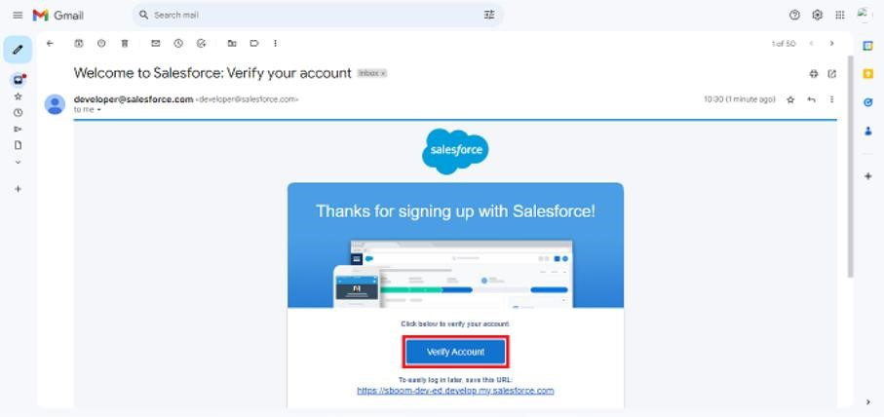

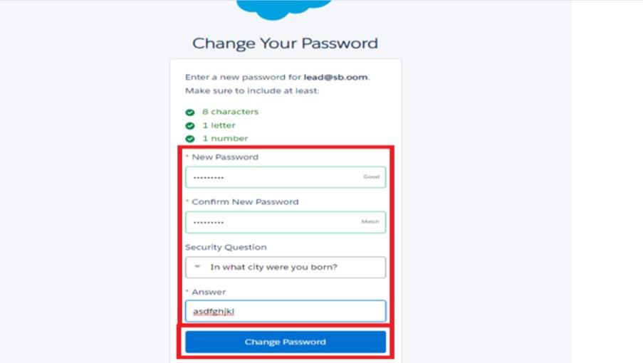

1. Then you will redirect to your salesforce setup page.

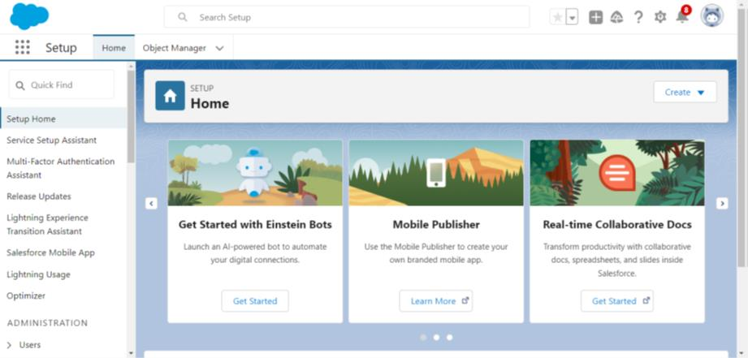

**Milestone 2- Object What Is an Object?**

Salesforce objects are database tables that permit you to store data that is specific to an organization.

**What are the types of Salesforce objects?**

**Salesforce objects are of two types:**

1. **Standard Objects:** Standard objects are the kind of objects that are provided by salesforce.com such as users, contracts, reports, dashboards, etc.
2. **Custom Objects:** Custom objects are those objects that are created by users. They supply information that is unique and essential to their organization. They are the heart of any application and provide a structure for sharing data.

In Salesforce, a custom object is a database table that allows you to store data unique to your organization. While Salesforce provides standard objects (like Account, Contact, Opportunity, etc.) that cover common CRM functions, custom objects let you define and manage data that's specific to your business.

**Use Case:**

Creating an object in a Salesforce organization is essential for efficient data management and process automation. By defining custom objects, businesses can structure and store data specific to their needs, enabling streamlined workflows, personalized reporting, and enhanced user experiences. Objects serve as the foundation for organizing and leveraging critical information within Salesforce.

As an Admin for TheSmartBridge, It’s your responsibility to store the data as per the organisation needs.

**Create Custom Objects**

To store the data as per business requirements.

**Activity 1: Create Tenant Object**

1. From the setup page ==> Click on Object Manager ==> Click on Create ==> Click on Custom Object.

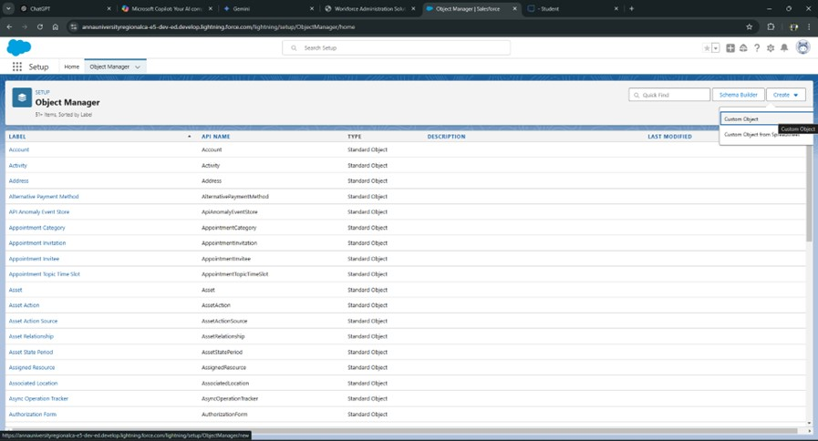

1. Enter the label name: Tenant
2. Plural label name: Tenants
3. Enter Record Name Label and Format
   * + Record Name: Tenant Name
     + Data Type: Text

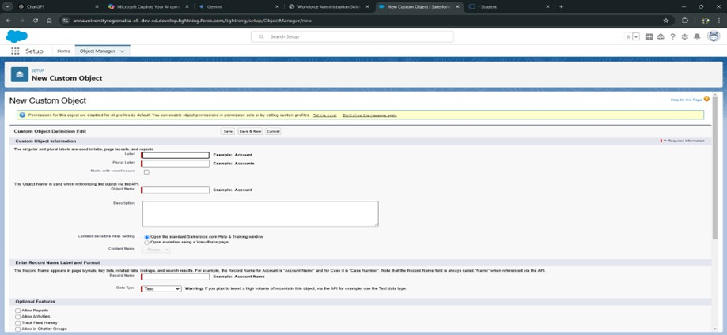

1. Click on Allow reports.
2. Allow search and Save

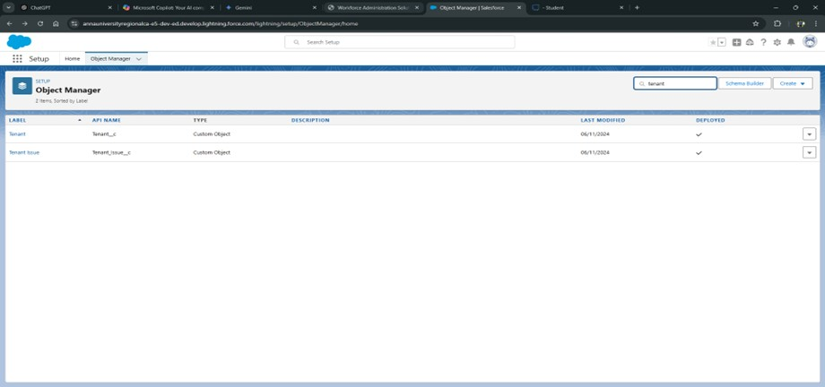

**Activity 2: Create Lease Tracking Object**

* 1. Enter the label name ==>Lease Tracking
  2. Plural label name ==> Leases Tracking
  3. Enter Record Name Label and Format
     + - Record Name: Lease Tracking No
       - Data Type: Auto Number ● Display Format - TT - {000000} 4. Click on Allow reports.

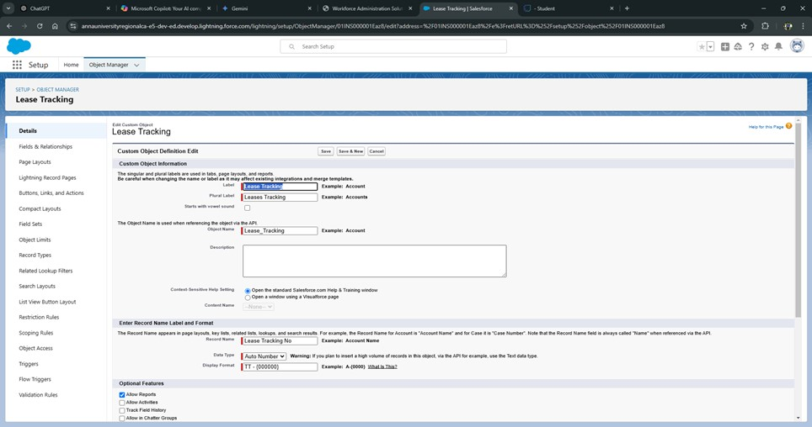

5. Allow search and Save.

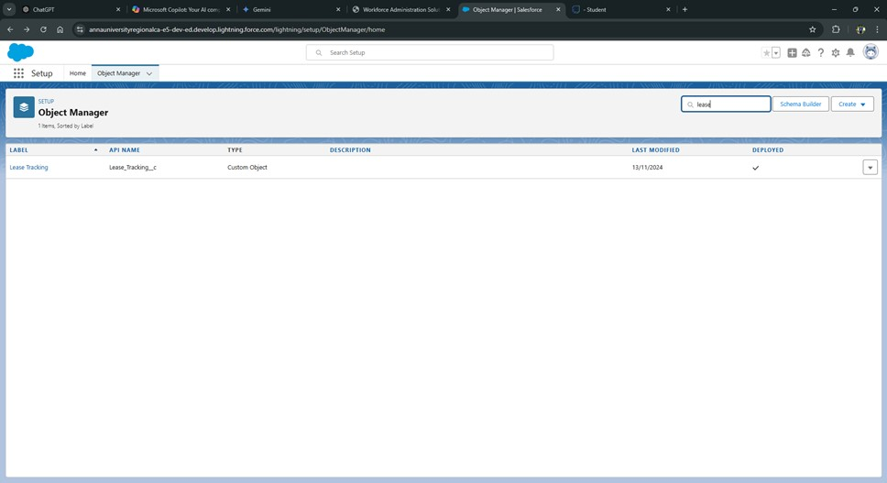

**Activity 3: Create Tenant Issues Object**

Enter the label name ==> Tenant Issue

* 1. Plural label name ==> Tenant Issues
  2. Enter Record Name Label and Format

● Record Name: Issues ● Data Type: Auto number

* 1. Click on Allow reports.



* 1. Allow search and Save.

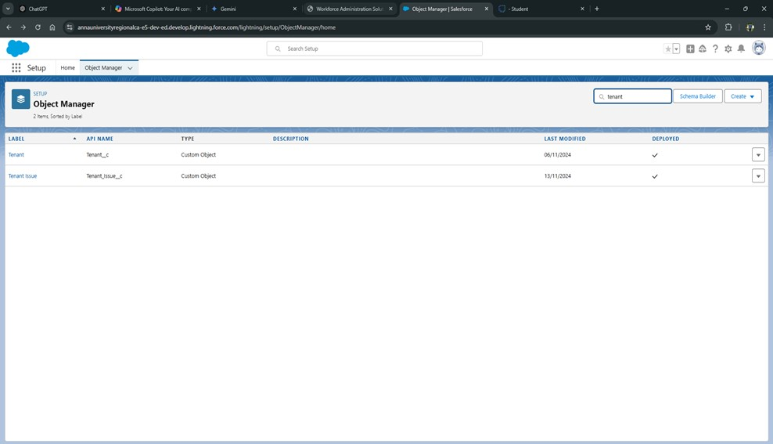

# Milestone 3- Tabs

**What is Tab?**

A tab is like a user interface that is used to build records for objects and to view the records

in the objects.

**Types of Tabs:**

1. **Custom Tabs:**

Custom object tabs are the user interface for custom applications that you build in salesforce.com. They look and behave like standard salesforce.com tabs such as accounts, contacts, and opportunities.

1. **Web Tabs:**

Web Tabs are custom tabs that display web content or applications embedded in the salesforce.com window. Web tabs make it easier for your users to quickly access content and applications they frequently use without leaving the salesforce.com application.

1. **Visualforce Tabs:**

Visualforce Tabs are custom tabs that display a Visualforce page. Visualforce tabs look and behave like standard salesforce.com tabs such as accounts, contacts, and opportunities.

1. **Lightning Component Tabs:**

Lightning Component tabs allow you to add Lightning components to the navigation menu in Lightning Experience and the mobile app.

1. **Lightning Page Tabs:**

Lightning Page Tabs let you add Lightning Pages to the mobile app navigation menu. Lightning Page tabs don't work like other custom tabs. Once created, they don't show up on the All Tabs page when you click the Plus icon that appears to the right of your current tabs. Lightning Page tabs also don't show up in the Available Tabs list when you customize the tabs for your apps.

**Use Case:**

Creating Objects and storing TheSmartBridge organization’s data is the very first step in the requirements they want. Now to access the stored data by an employee from the organization Admin needs to create Tabs. By designing a dedicated Tab, businesses can improve user experience, simplify navigation, and provide quick access to critical information, enhancing productivity and ensuring efficient utilization of Salesforce's capabilities.

**Activity 1: Create a custom tab for the tenant object**

object tab).

Select Object (Tenant) ==> Select the tab style ==> Next (Add to profiles page) keep it as default ==> Next (Add to Custom App) uncheck the include tab ==> Save. Make sure to append a tab to users' existing personal customizations is checked.

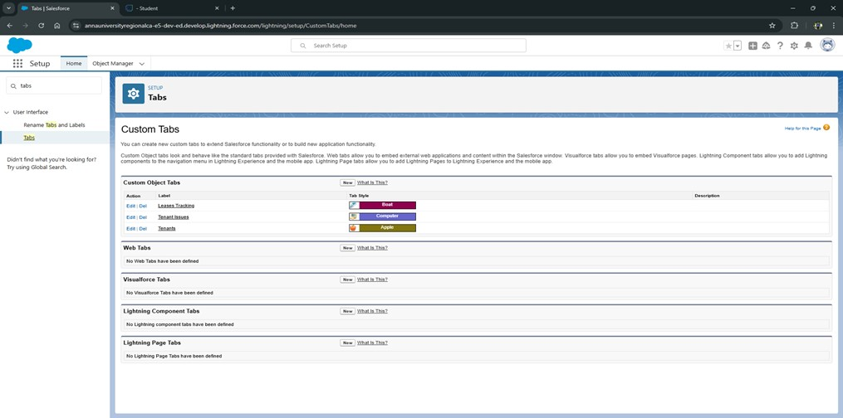

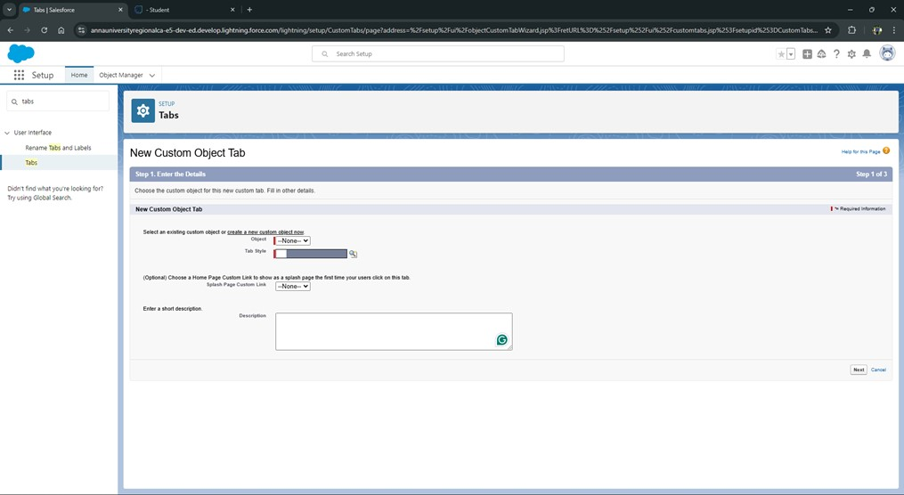

**Activity 2: Create a custom tab for the Lease Tracking object**

object tab).

Select Object (Lease Tracking) ==> Select the tab style ==> Next (Add to profiles page) keep it as default ==> Next (Add to Custom App) uncheck the include tab ==> Save. Make sure to append a tab to users' existing personal customizations is checked.





**Activity 3: Create a custom tab for the Tenant Issue object**

object tab).

Select Object (Tenant Issues) ==> Select the tab style ==> Next (Add to profiles page) keep it as default ==> Next (Add to Custom App) uncheck the include tab ==> Save. Make sure to append a tab to users' existing personal customizations is checked.





# Milestone 4 - Create Fields and Relationships

**What is Field?**

Fields in Salesforce are individual data points that belong to a Salesforce object (like Account, Contact, Opportunity, or custom objects). Each field in an object is akin to a column in a spreadsheet and is used to capture specific information about a record. Salesforce offers various types of fields, including:

* Standard Fields: Predefined fields available in every Salesforce org, such as Name, Created Date, Owner, etc.
* Custom Fields: User-defined fields created to meet specific business needs, allowing customization beyond the standard fields.
* Field Types: Fields come in various types, such as Text, Number, Date, Checkbox, Picklist, Lookup, and Formula fields, allowing data to be structured appropriately.

**What is Relationships?**

Relationships in Salesforce define how two or more objects are connected, enabling data to be linked and managed across different records. Salesforce supports several types of relationships:

* Lookup Relationship: A loosely coupled relationship where one object can link to another, but records can exist independently. For example, a Contact record may have a lookup relationship to an Account, but deleting the Account won’t delete the Contact.
* Master-Detail Relationship: A tightly coupled relationship where one object depends on another. In a master-detail relationship, the detail (or child) record is deleted if the master (or parent) record is deleted. For example, Opportunity Line Items are dependent on an Opportunity.
* Many-to-Many Relationship: This relationship requires a junction object to link two objects in a many-to-many structure. For instance, a Course object and a Student object might be related in a many-to-many fashion using a Course Enrollment junction object.
* Hierarchical Relationship: A special type of relationship available only for the User object, allowing it to relate to itself in a hierarchical structure, like a manager and employee relationship.

**Use Case:**

In Salesforce, fields and relationships structure data for efficient tracking and management.

Fields capture specific data points, like a Contact’s `Name` and `Email`, on individual records. Lookup Relationships link objects with flexible connections, such as associating Contacts with Accounts, while still keeping them independent. Master-Detail Relationships enforce dependency, ensuring child records, like Opportunity Line Items, get deleted if the parent Opportunity is removed.

Lastly, Many-to-Many Relationships use junction objects to associate objects like `Courses` and `Students`, allowing each student to enroll in multiple courses and vice versa.

**Activity 1: Create Fields on the Tenant object**

1. Setup and click on setup.
2. You will now be navigated to the setup page, click on object manager and search for the object “Tenant”.
3. Click on “Fields & Relationships” in the left panel.

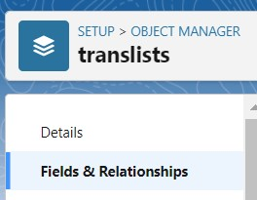

1. Click on New and choose the data type Phone and first name: Phone Number.
2. Click next and fill in the following details in the mentioned.

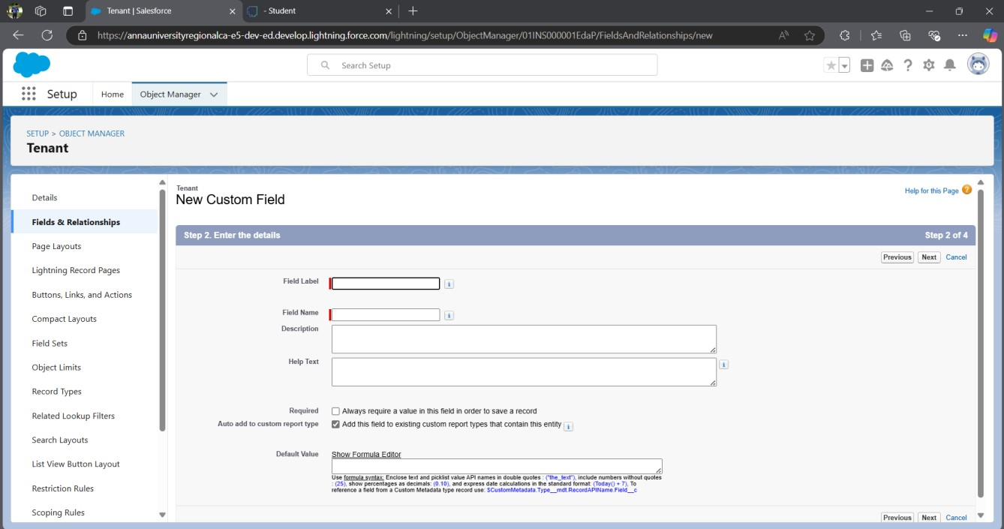

1. Click Next, Next, and click on “Save and New”.

Note: Repeat the same steps to create the fields :

|  |  |  |
| --- | --- | --- |
| **S No** | **Field Label** | **Data Type** |
| 1 | Address | Text Area(255) |
| 2 | PAN Card | Text |
| 3 | Date of Reg | Date |
| 4 | Email | Email |
| 5 | GST No | Text |
| 6 | Registered License No | Text |
| 7 | Shop Act license No | Text |
| 8 | Status of possession | Pick List    Pending Hand Over Renewal  Needed Closed |

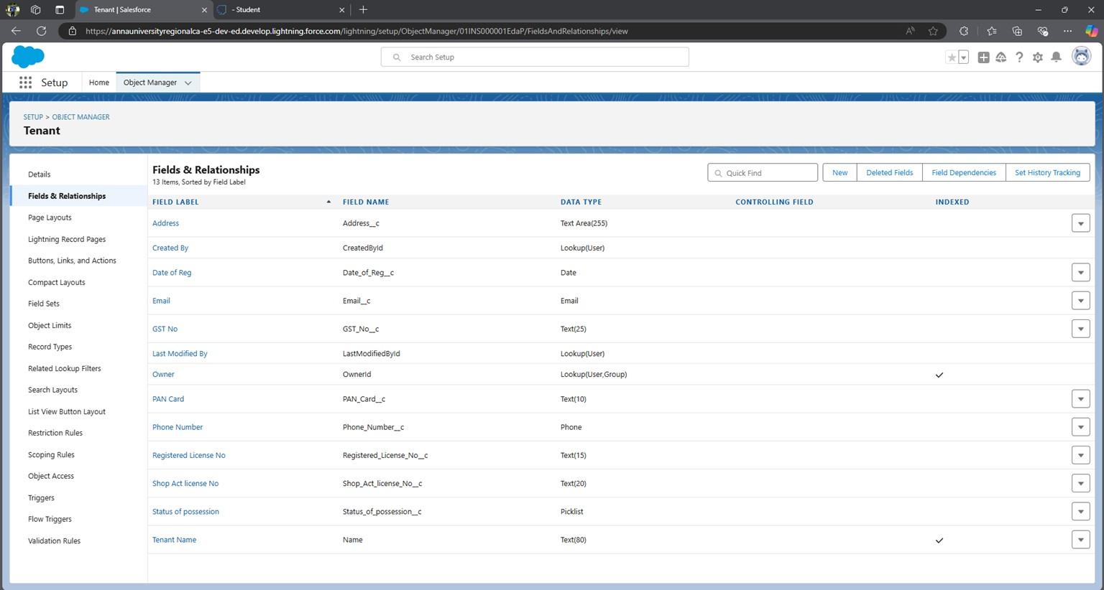

**Create Validation Rules for Tenant Object:**

1. Create validation rule for Phone Number -

Note:- check if the Phone Number is valid having 10 digits if not then show an error.

* 1. Go to setup ==> click on Object Manager ==> type object name(Tenant) in quick find bar==>click on the object.

2.

Click on the

validation rule ==> click New.

3.

Enter the Rule name as “Phone Validation “.

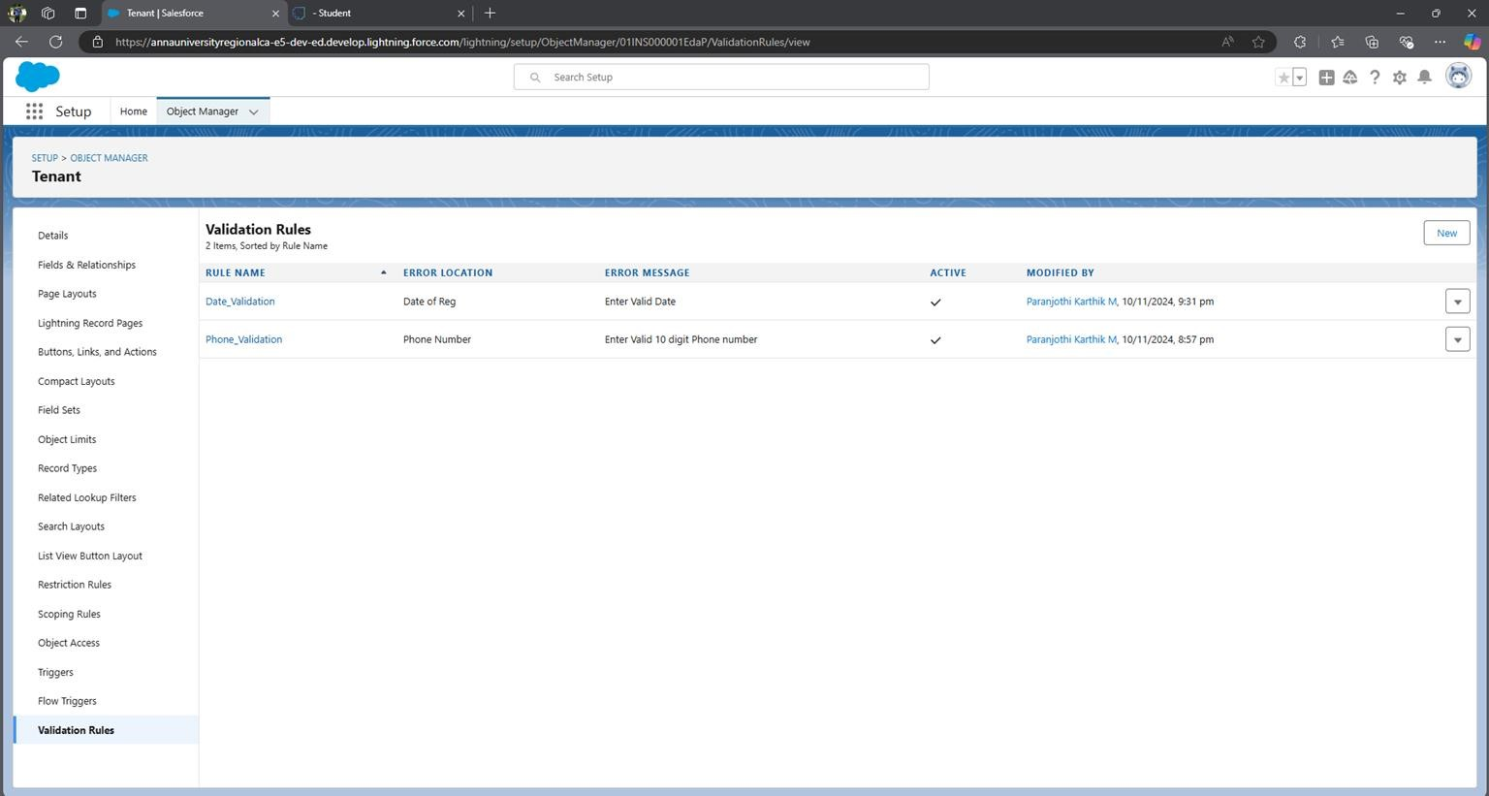

* 1. Insert the Error Condition Formula as: -

NOT(OR(REGEX( Phone_Number__c , "^[0-9]{10}")))

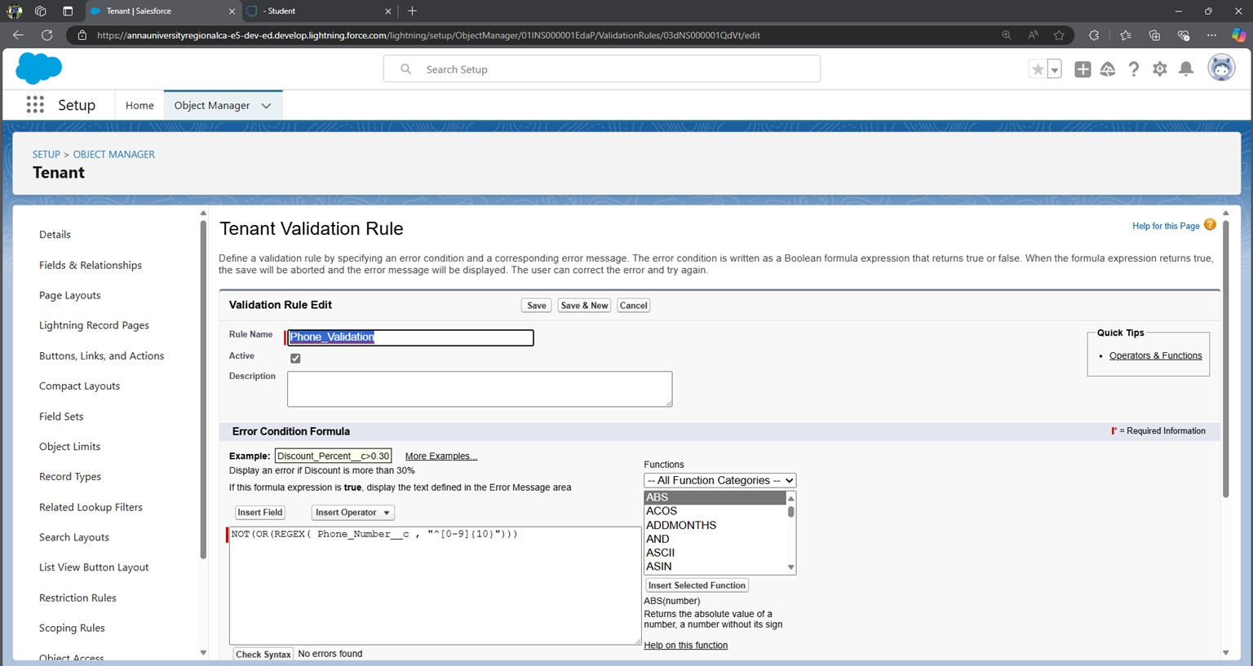

* 1. Enter the Error Message as “Enter Valid 10 digit Phone number”, select the Error location as

Field and select the field as “Phone Number”, and click Save

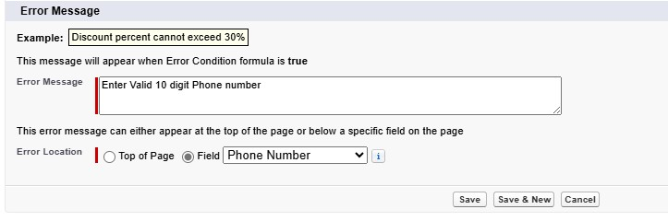

1. **Create a Validation rule for the Date of Reg :**

Note:- check if the DateofReg is valid and is not a Date in the past.

* 1. Go to setup ==> click on Object Manager ==> type object name(Tenant) in quick find bar==> click on the object.
  2. Click on the validation rule==> click New.
  3. Enter the Rule name as “Date Validation “. 4. Insert the Error Condition Formula as: - Formula: DateofReg__c < TODAY()

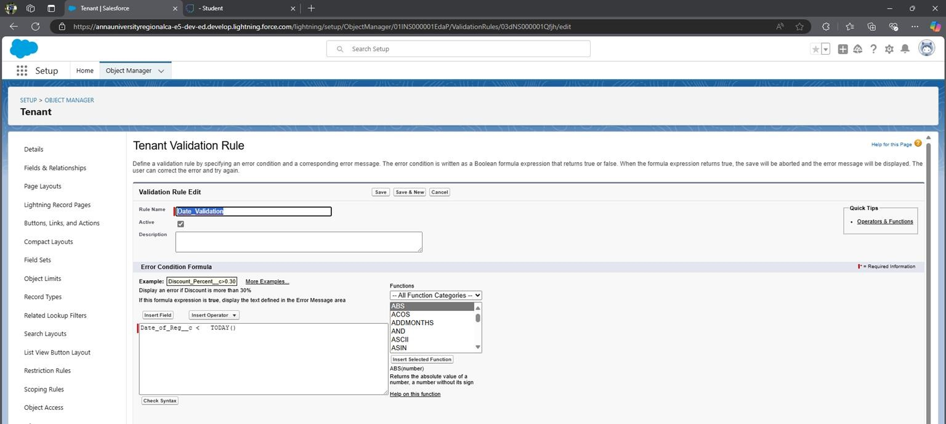

5. Enter the Error Message as “Enter Valid Date”, select the Error location as Field and select the field as “DateOfReg”, and click Save.

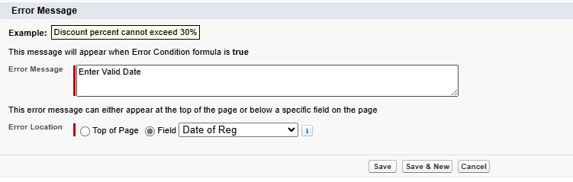

**Activity 2: Create fields on the Lease Tracking Object**

* 1. Setup and click on setup.
  2. You will now be navigated to the setup page, click on object manager and search for the object “Lease Tracking”.
  3. Click on “Fields & Relationships” in the left panel.

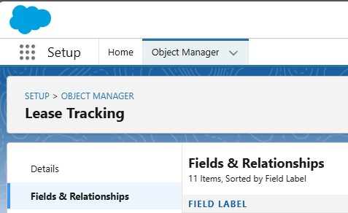

* 1. Click on New and choose the data type Date and first name: Date of Possession.
  2. Click next and fill in the following details in the mentioned.

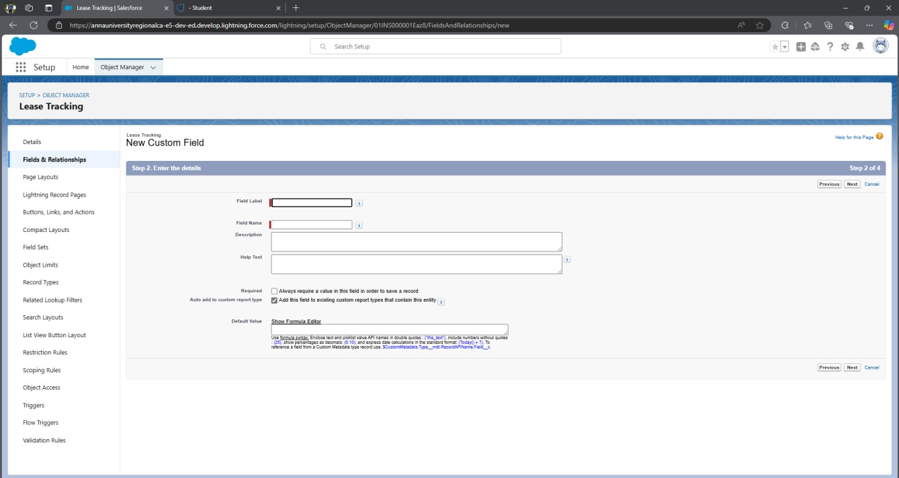

* 1. Click Next, Next, and click on “Save and New”.

NOTE: - Fields in lease Tracking objects are as follows below data types:

|  |  |  |
| --- | --- | --- |
| S No | Field Label | Data Type |
| 1 | Related Tenant | Master-Detail Relationship (Related to - Tenant) |
| 2 | Date of Possession | Date |
| 3 | End Date of  Possession | Date |
| 4 | Total Year of  Contract | Number |
| 5 | Total rent(Yearly) | Number |
| 6 | Amount Paid | Number |
| 7 | Amount to be paid | Formula field  (Total Rent - Amount Paid)  Return Data Type- Number |

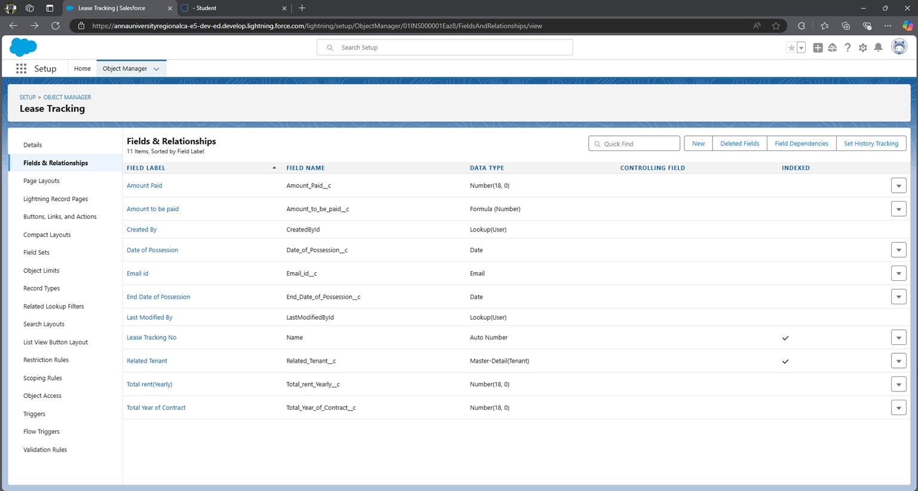

**Create Validation Rule For Lease Tracking Object :**

A) Create a Validation rule on the Date of Possession-

Note:- check if the Date of Possession is 60 days from today or not if not then show an error.

1. Go to setup ==> click on Object Manager ==> type object name(Lease tracking) in quick find bar==>click on the object.

2.

Click on the validation rule ==> click New.

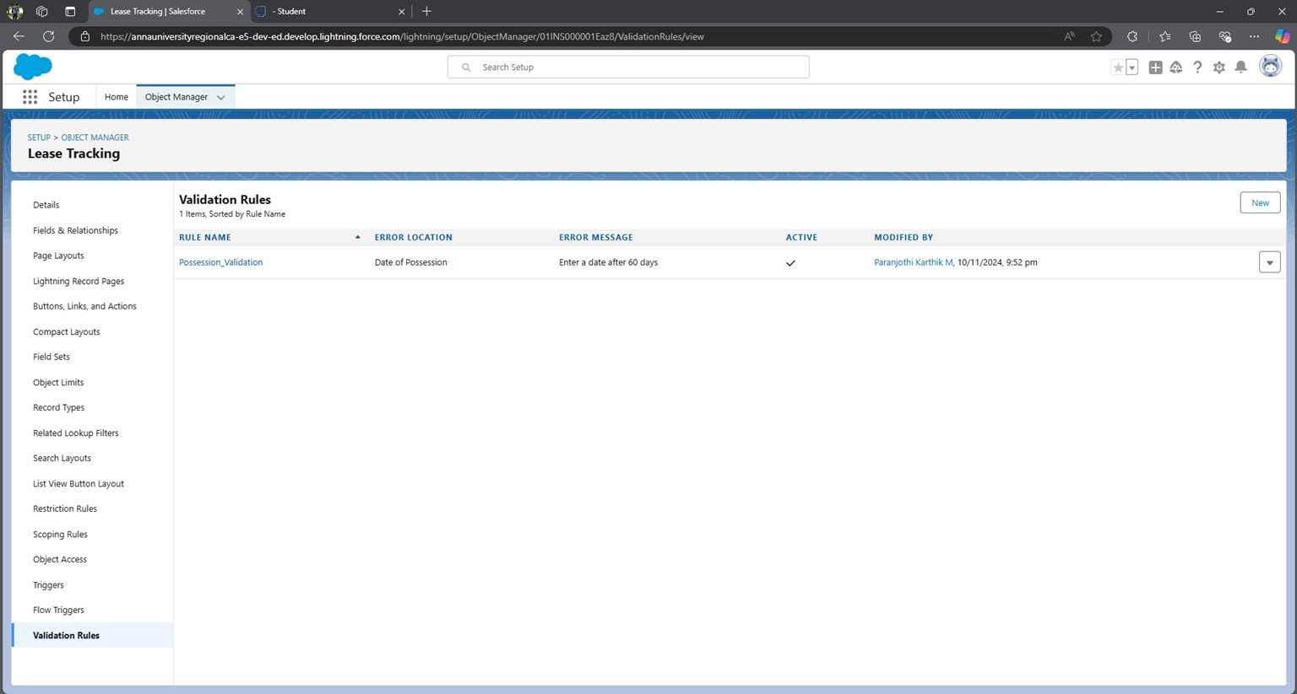

1. Enter the Rule name as “Possession Validation“.

1. Insert the Error Condition Formula as: -

Formula: Date of Possession < TODAY() + 60

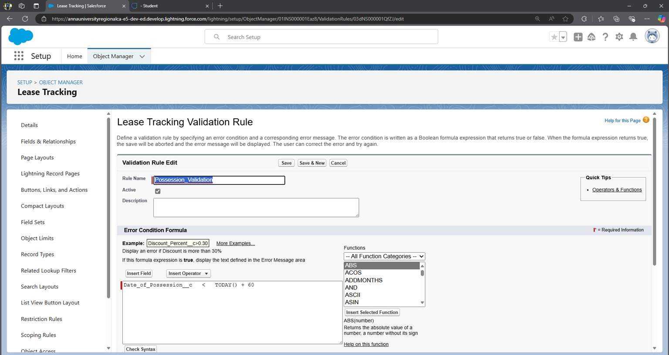

1. Enter the Error Message as “Enter a date after 60 days ”, select the Error location as Field select the field as “DateofPossession”, and click Save.

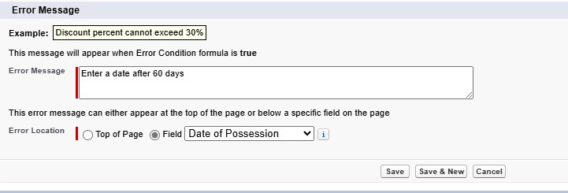

**Activity 3: Create fields on Tenant Issues**

1. Setup and click on setup.
2. You will now be navigated to the setup page, click on object manager and search for the object

“Lease Tracking”.

1. Click on “Fields & Relationships” in the left panel.

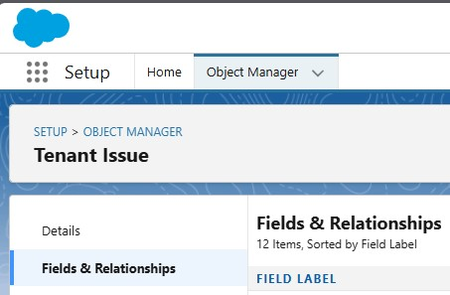

1. Click on New and choose the data type Date and first name: Date of Possession.
2. Click next and fill in the following details in the mentioned.

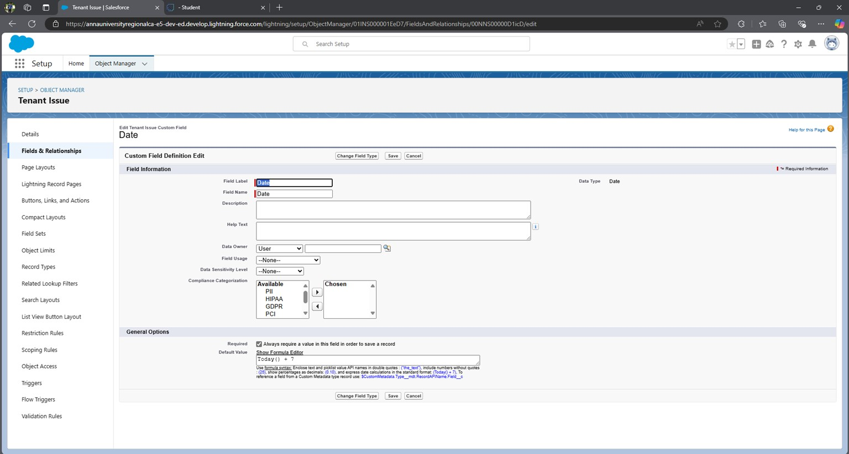

1. Click Next, Next, and click on “Save and New”.

NOTE: Fields in lease Tenant Issues are as follows below data types-

|  |  |  |  |
| --- | --- | --- | --- |
| **S No** | **Field Label** | **Data Type** | |
| 1 | Related tenant | Master-Detail Relationship (Related to - Tenant) | |
| 2 | Issue Related to | 2) | Multi Select Picklist  1) ELECTRICITY  INFRASTRUCTURE   1. PLUMBING 2. RENT 3. OTHER |
| 3 | Subject |  | Text Are (long) |
| 4 | Phone Number |  | Number |
| 5 | Status |  | Pick List |
|  |  | 1. | Not contacted |
|  |  | 2. | Open |
|  |  | 3. | In progress |
|  |  | 4. | Working |
|  |  | 5. | closed |
| 6 | Priority |  | Picklist |
|  |  | 1. | Low |
|  |  | 2. | Medium |
|  |  | 3. | High |
| 7 | Origin |  | Picklist |
|  |  | 1. | Phone |
|  |  | 2. | Mail |
|  |  | 3. | Web |
| 8 | Email id |  | Email |
| 9 | Date |  | Date |
|  |  | (Default Value - Today()) | |

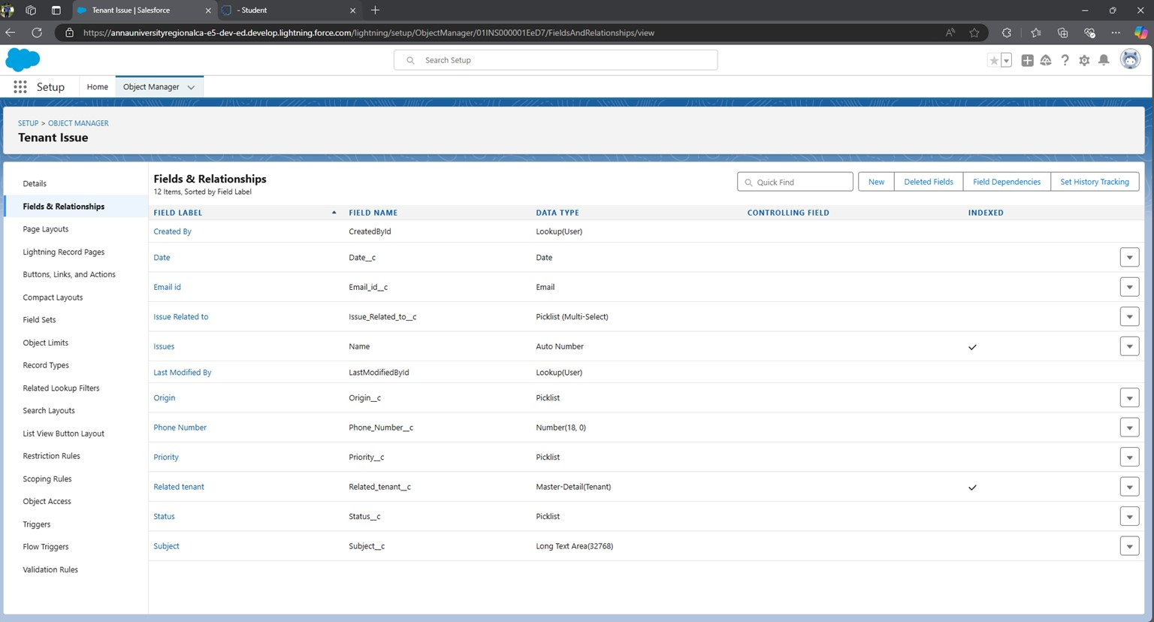

# Milestone 5 - Create the Lightning App

An app is a collection of items that work together to serve a particular function. In Lightning Experience, Lightning apps give users access to sets of objects, tabs, and other items all in one convenient bundle in the navigation bar.

**Lightning apps** let you brand your apps with a custom color and logo. You can even include a utility bar and Lightning page tabs in your Lightning app. Members of your org can work more efficiently by easily switching between apps.

There are two types of Salesforce Applications:

* Standard Apps
* Custom Apps

**Standard Apps:**

Standard apps come with Salesforce as the default for every occurrence. Community, Call Center, Content, Sales, Marketing, Salesforce Chatter, Site.com, and App Launcher are included in these apps. The description, logo, and label of a standard app cannot be altered.

**Custom Apps:**

Custom apps are created according to the needs of a company. They can be made by putting custom and standard tabs together. Logos for custom apps can be changed.

**Use Case:**

Well done you have reached close to your organizational requirement by creating the objects to store the organization’s data. Making a database for an organization is just not enough to reach out the requirements, the task is how the users at the organisation can access the objects you have created for them. As an Admin for the TheSmartBridge organization, it's your duty to make sure every user of the organization is able to access the data modeling structure.

## Activity 1: Steps to create a custom app in Salesforce

1. Go to setup, by clicking the gear icon present in the top right corner.
2. Navigate to the Home bar and in the quick find box, search for App.
3. Click on APP MANAGER.
4. You can notice the screen like this. Now click on New Lightning App.You will find like this below.

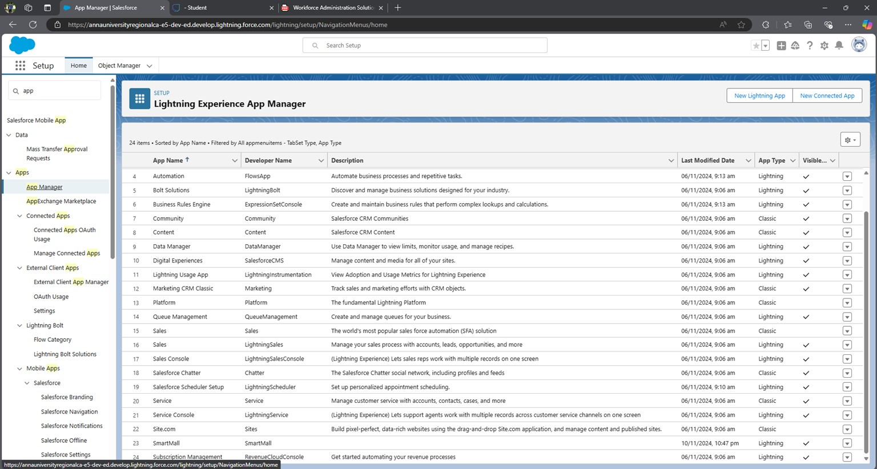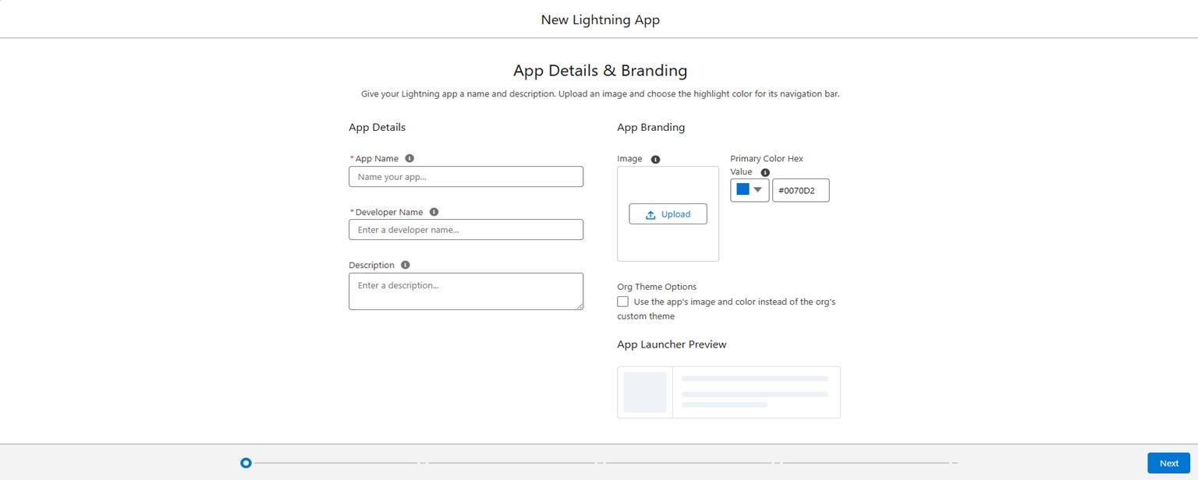

1. Enter the App name( Here we entered ‘SmartMall’),the developer name gets automatically populated. If an image is required, you can browse the image and upload it.
2. Click Next, Next and you can see a Navigation Items window like this:

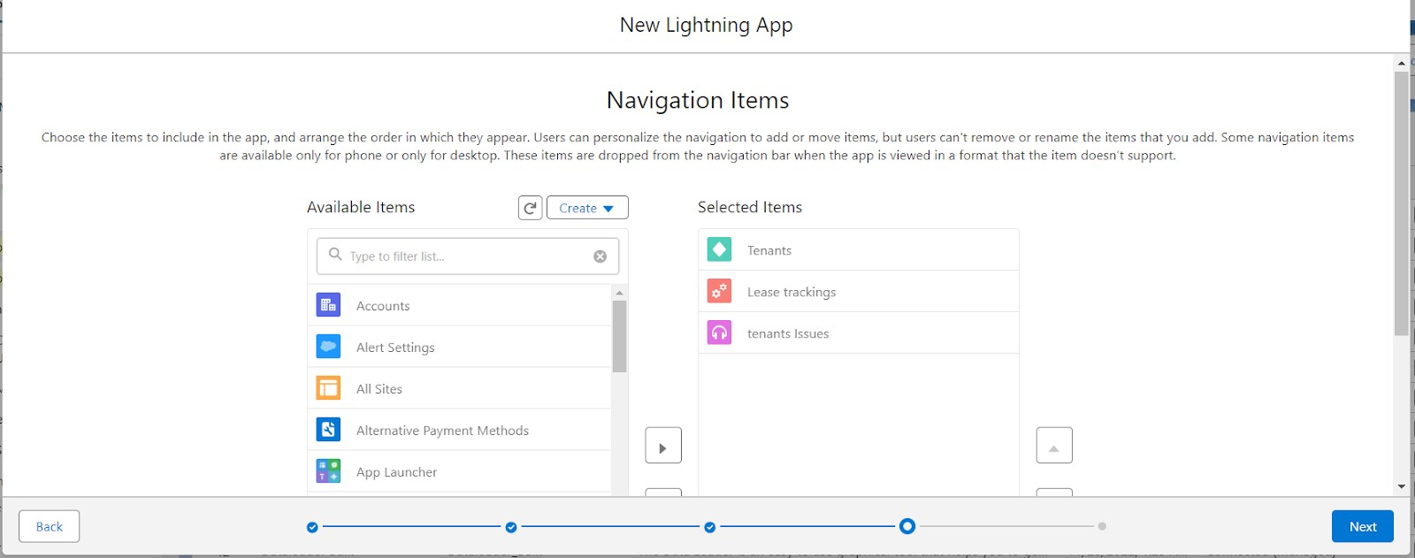

1. In the filter list, enter Tenant, Lease Tracking, and Tenant issues, and move them to the Selected items from Available items.

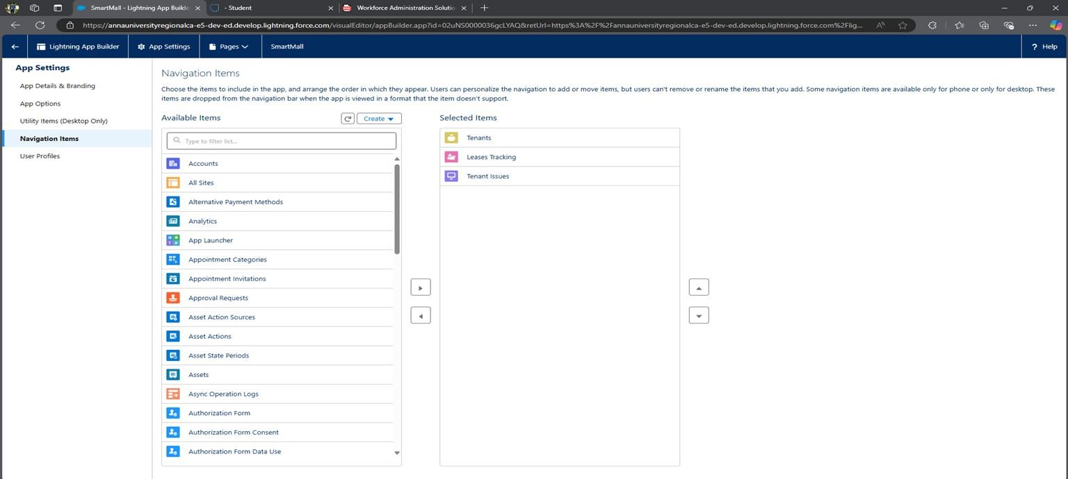

1. Click on Next, and you will see User Profiles. This option is used when we want only certain profiles to have access to them.
2. Enter System Administrator in the filter box and add the system Administrator to the selected profile list.

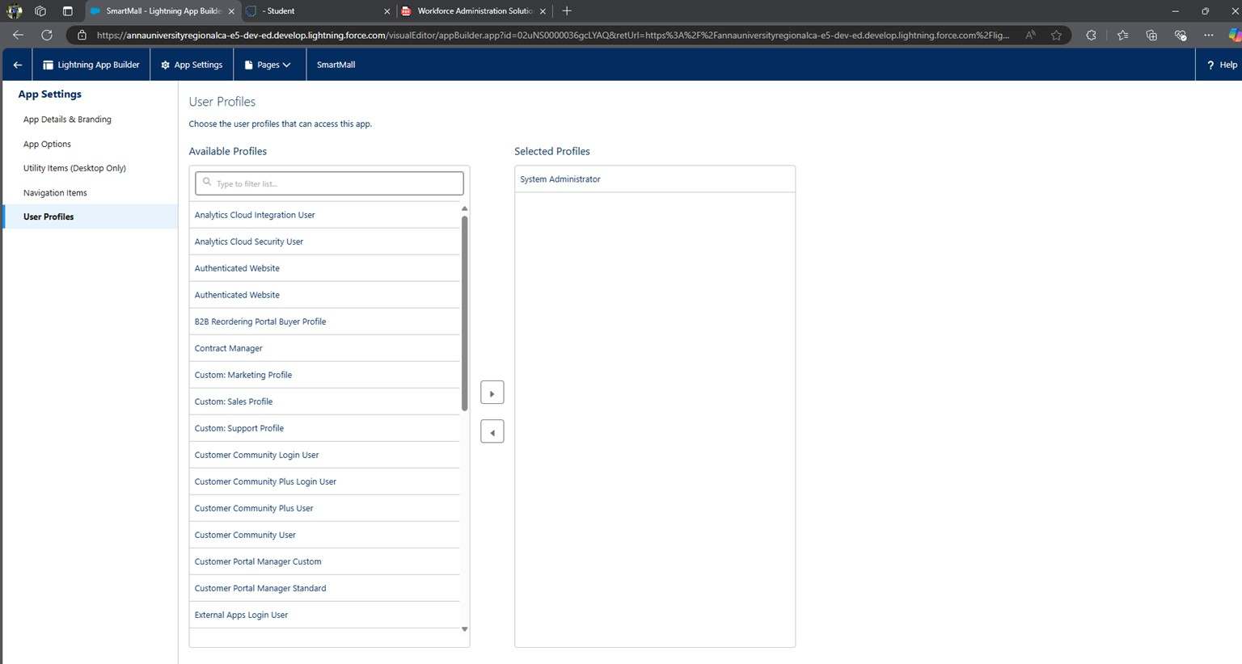

1. Click on Save and Finish.
2. Now navigate to the App launcher and search for SmartMall and you can find the SmartMall app.

# Milestone 6 - Record Insertion

Creating records in Salesforce is a fundamental and essential activity that serves multiple purposes, contributing to the effective management of data, streamlined processes, and the overall success of an organization.

Record insertion in Salesforce is the process of creating new records (like leads, accounts, contacts, opportunities, etc.) in the Salesforce database. There are various ways to insert records in Salesforce, depending on your needs and access:

1. **Manual Entry**: You can create records manually by navigating to a specific object (like Accounts or Contacts) and filling out the required fields.
2. **Data Import Wizard**: This tool is useful for bulk data entry. It allows you to import data from a CSV file into Salesforce and automatically map fields. It’s ideal for simple inserts and is accessible from the Salesforce setup menu.
3. **Data Loader**: This is a more powerful tool for bulk data operations, suitable for inserting, updating, and deleting large data sets (up to millions of records). It also supports scheduling, so you can set up regular batch imports.
4. **APEX DML (Data Manipulation Language)**: If you are a developer, you can use APEX code to insert records programmatically. This is helpful when building custom logic or automation around the record creation process.
5. **API Integration**: Salesforce provides a REST and SOAP API that allows third-party applications to insert records into Salesforce. This is often used for integrating Salesforce with other systems, enabling real-time data flow between platforms.

**Use Case:**

In Salesforce, record insertion is essential for maintaining up-to-date customer and operational data. For small-scale data entry, **manual entry** is straightforward and effective, allowing users to create individual records directly within Salesforce. For bulk data import, the **Data Import Wizard** offers a simple, guided experience suitable for moderate volumes of data, enabling users to upload CSV files and map fields automatically. When handling large-scale data imports or regularly scheduled updates, the **Data Loader** is a powerful tool that supports bulk data manipulation, including inserts, updates, and deletes. Developers needing custom logic for record insertion can utilize **APEX DML** to programmatically create records, embedding logic to automate processes. For integration with external systems, **API Integration** provides REST and SOAP endpoints, allowing third-party applications to insert records into Salesforce in real-time, making it ideal for synchronizing data between platforms.

**Activity 1: Inserting Records in Tenant Object**

1. Click on the App Launcher and search Tenant Object then click New in the right corner to create a record.

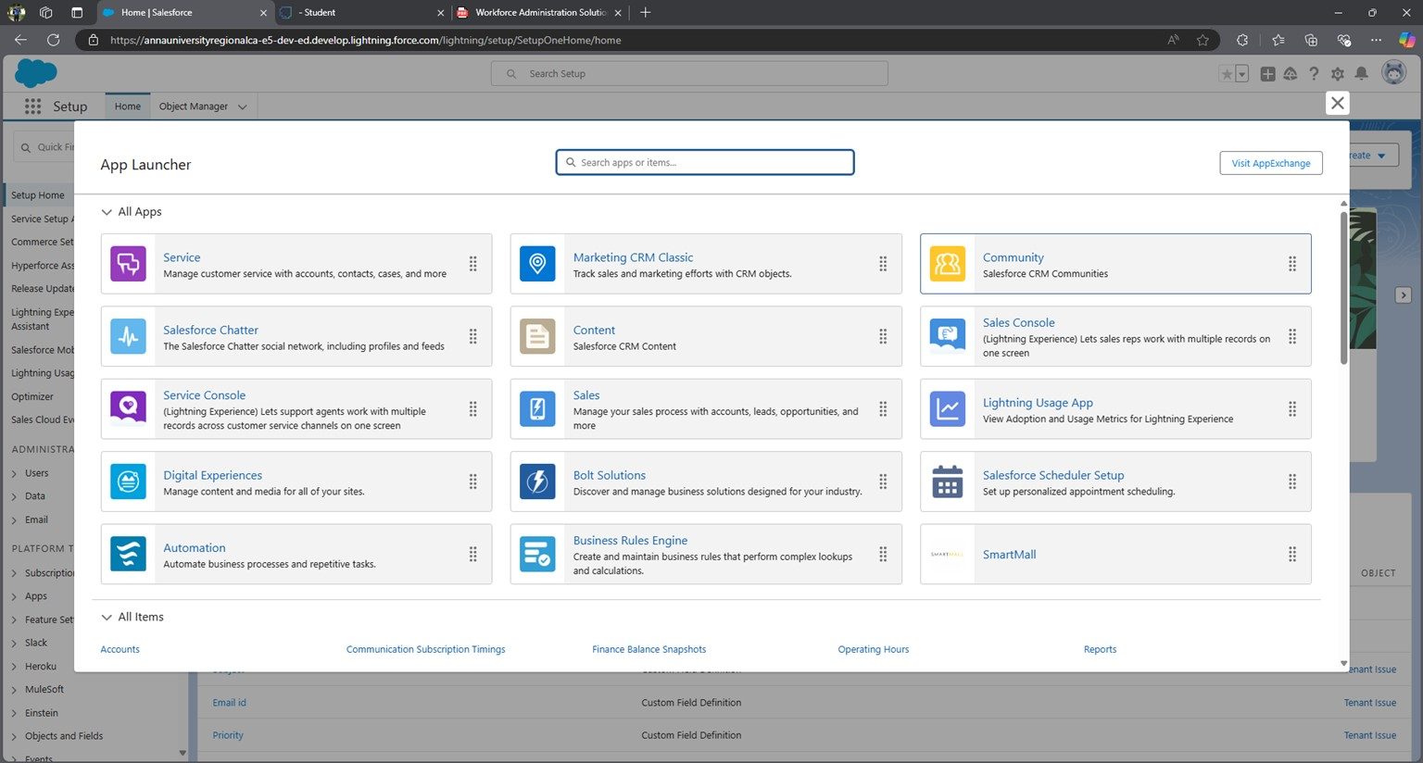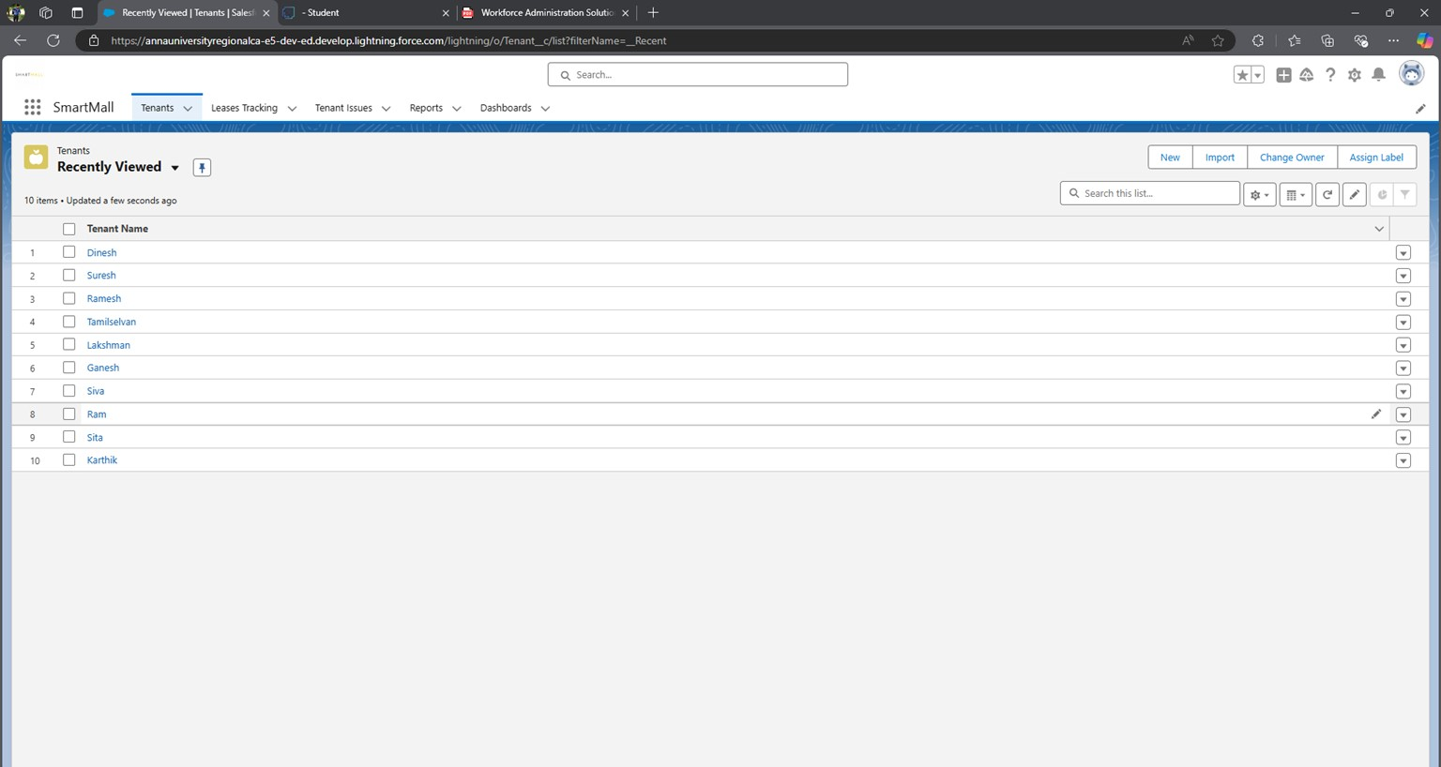

1. Fill every field with valid data, especially the fields on which you have created a validation rule.

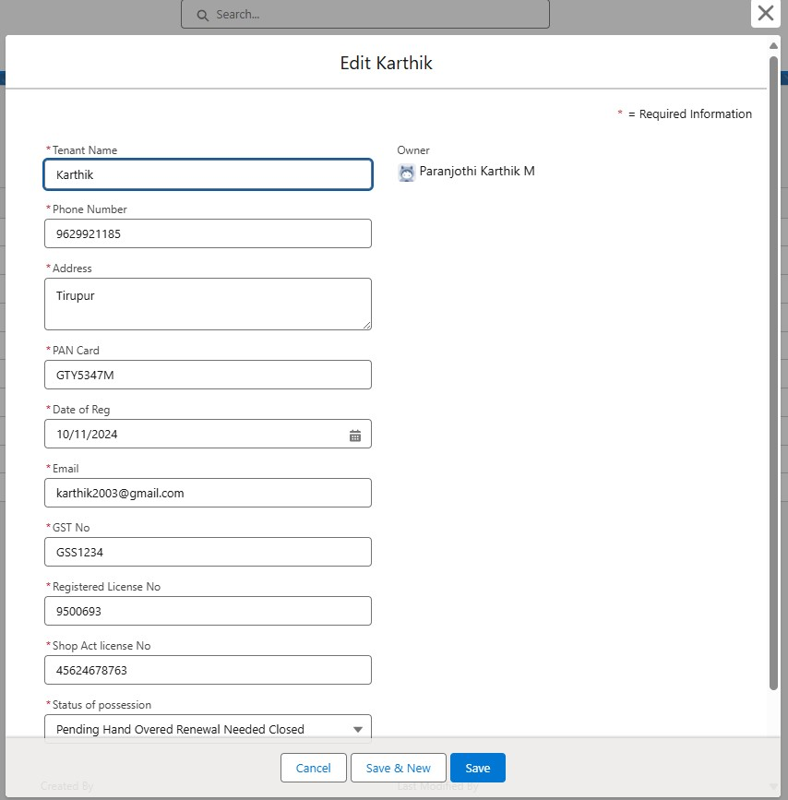

1. If you Enter a Phone Number of more or less than 10 digits it will show an error.
2. Similarly, if you enter DateofReg a Past date it will show an error.
3. After creating a record the page will look like this

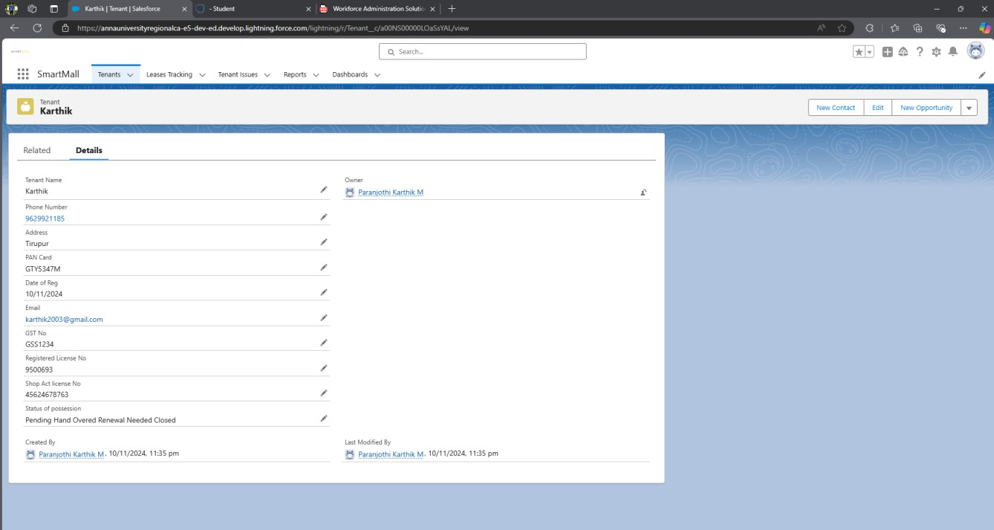

[ Note]: Create at least 10 records in the tenant object.

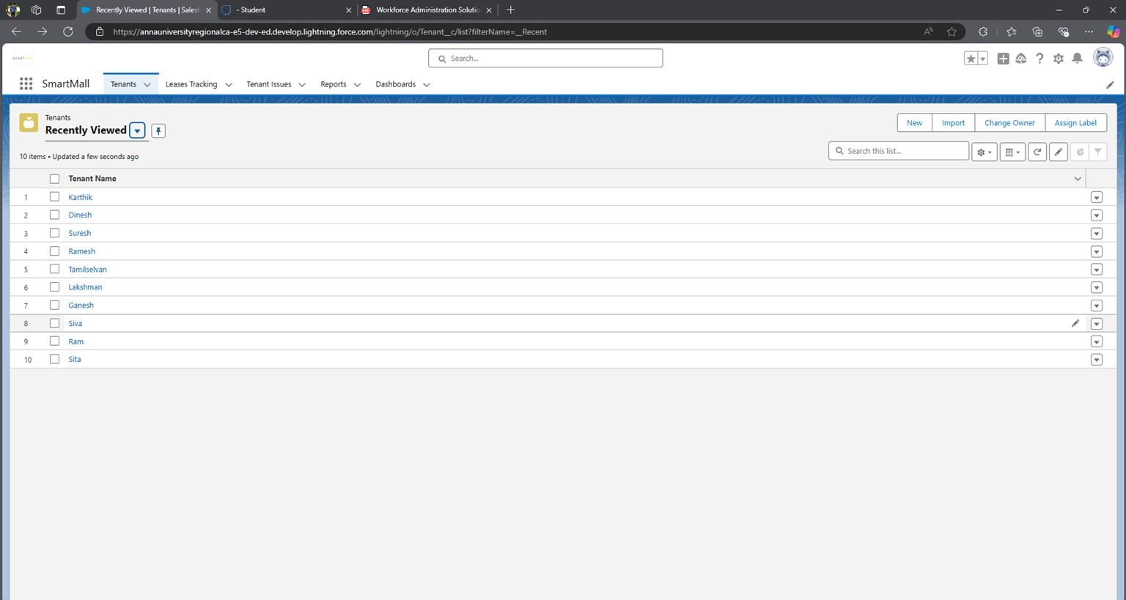

**Activity 2: Inserting Records in Lease Tracking Object**

* 1. Click on the App Launcher and search Lease Tracking Object then click New in the right corner to create a record.

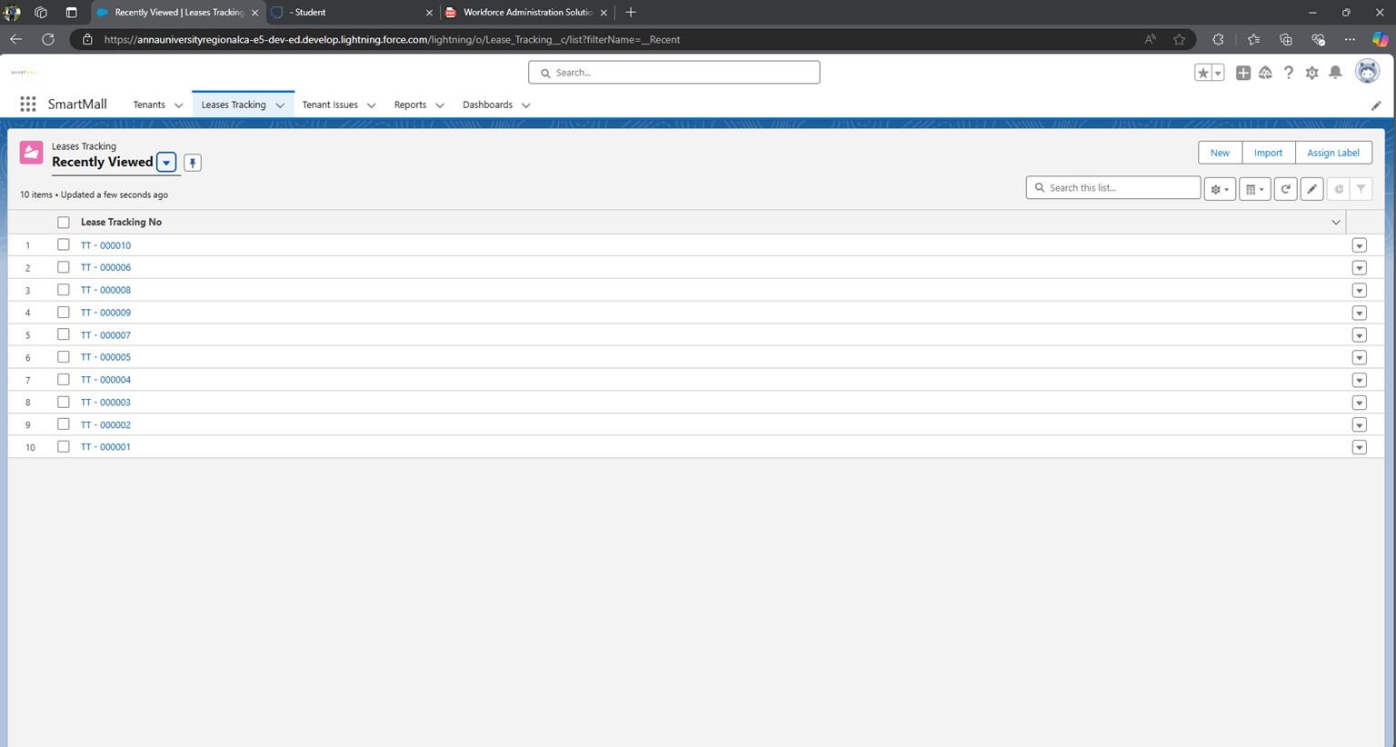

* 1. Fill every field with valid data, especially the fields on which you have created a validation rule, and Give each tenant related to each lease tracking.

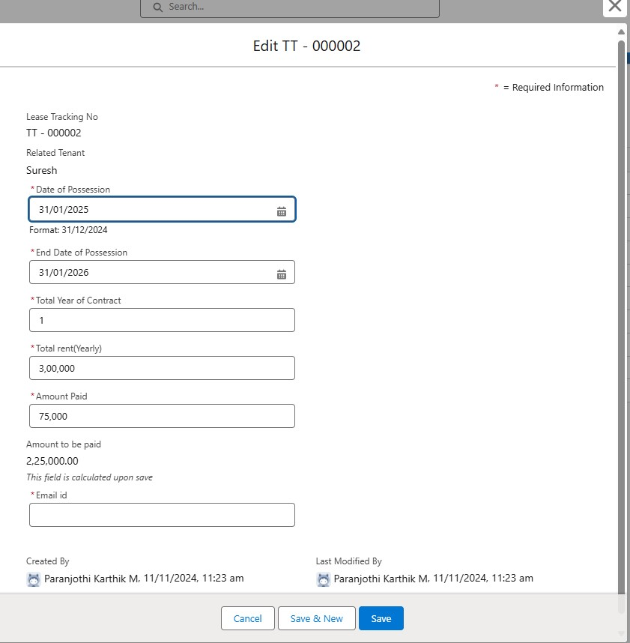

* 1. If you Enter a Date before the next 60 days it will show an error.
  2. Similarly, if you enter Total rent and Amount Paid the Amount to be paid formula field will be added directly.
  3. After creating a record the page will look like this

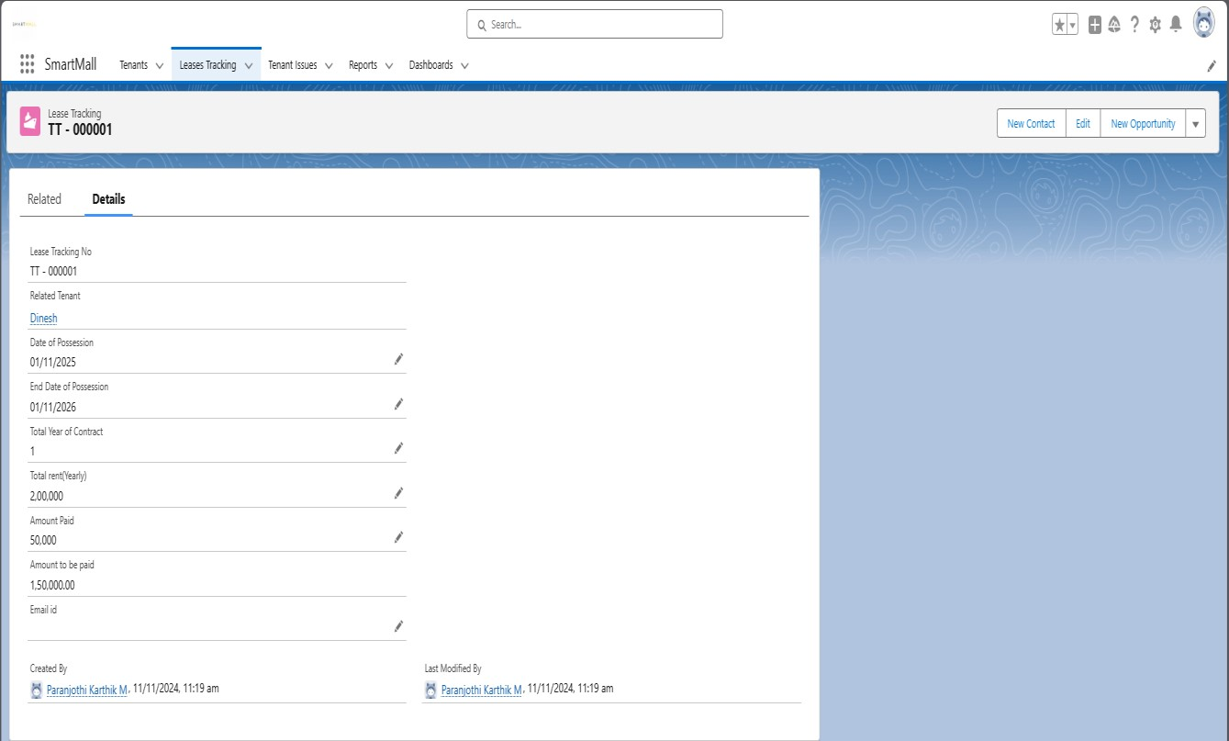

[ Note]: Create at least 10 records in the Lease Tracking object.

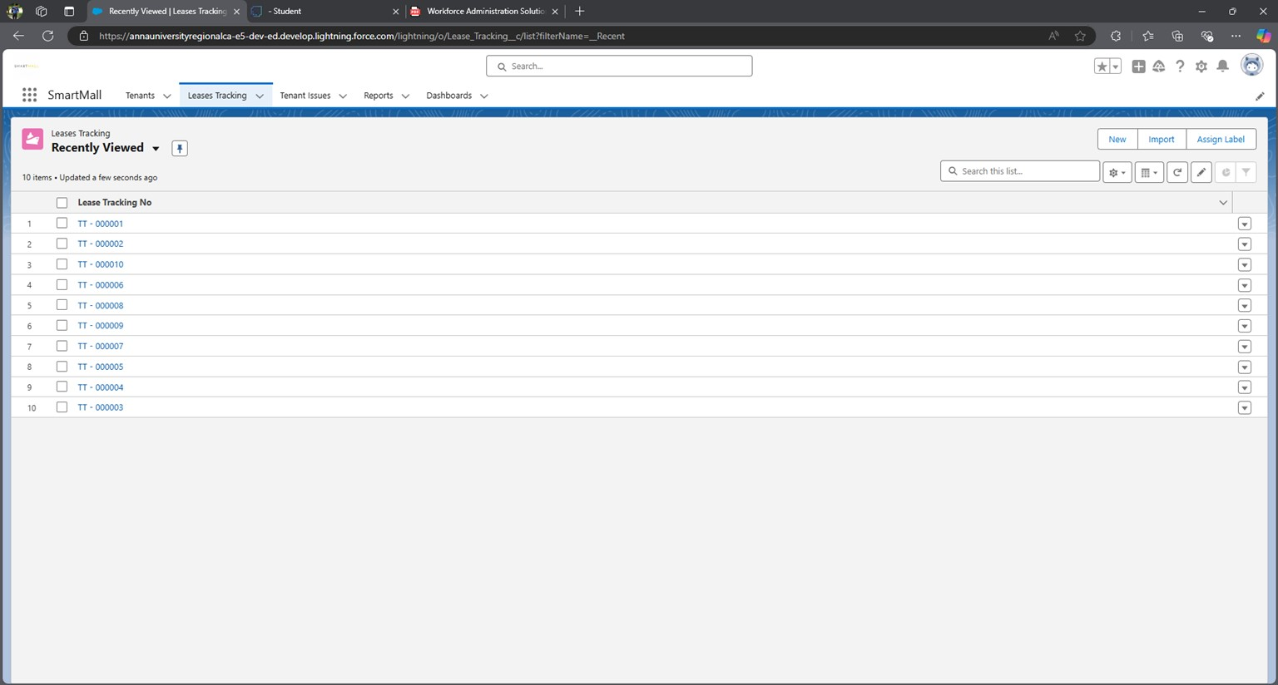

**Activity 3: Inserting Records in Tenants Issues object**

* + 1. Click on the App Launcher and search Tenant Issues Object then click New in the right corner to create a record.
    2. Fill every field with valid data.
    3. Give each tenant related to each issue.
    4. After creating a record the page will look like this

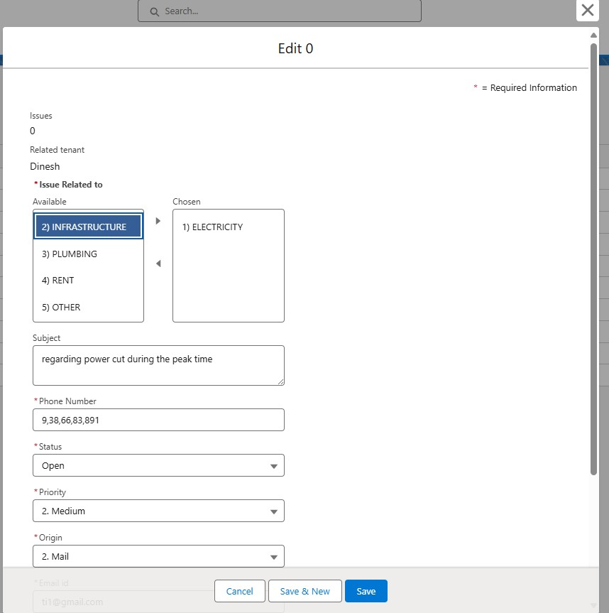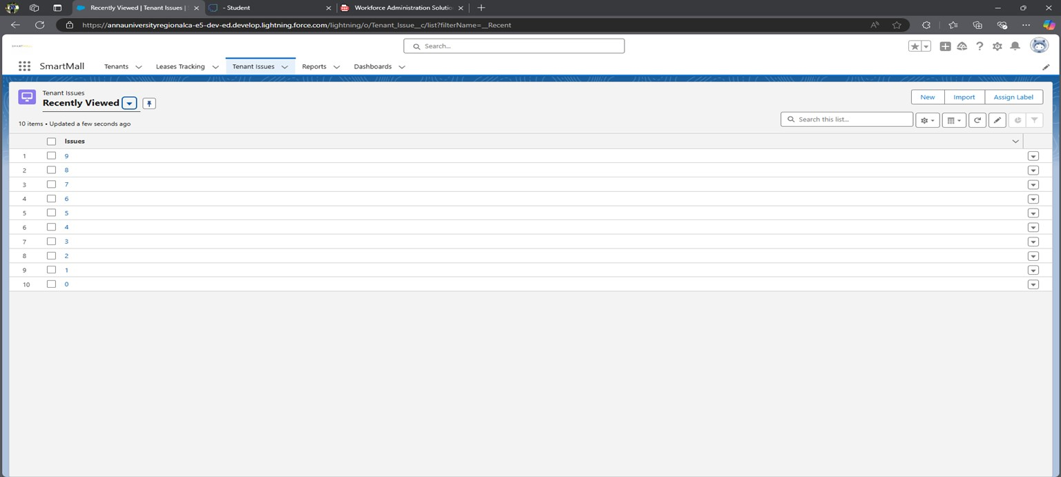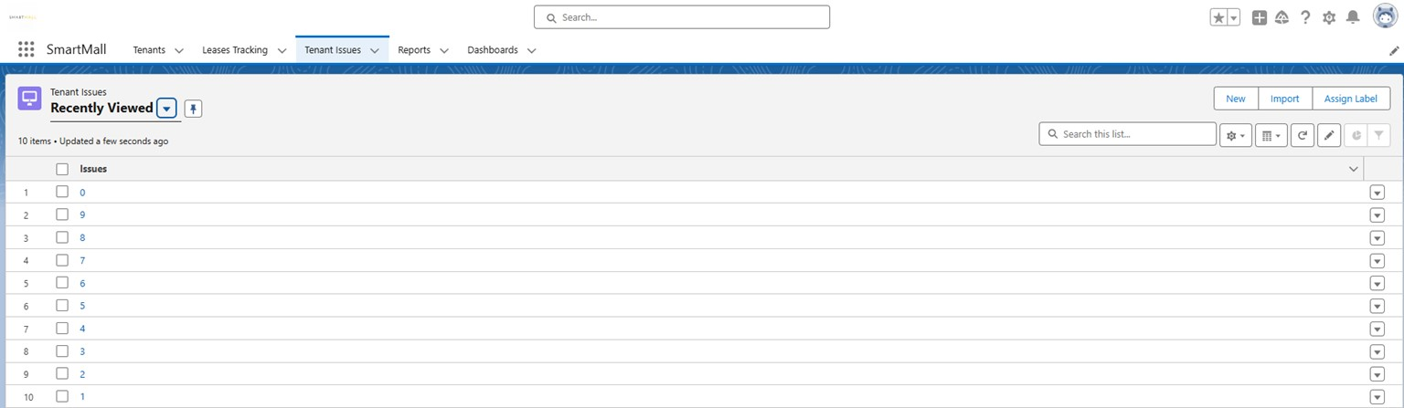

Note: Create at least 10 records in the tenant issues object.

# Milestone 7 - Create Flows

In Salesforce, a **Flow** is an automation tool that allows users to build complex workflows and processes using a visual interface. It enables businesses to automate repetitive tasks, streamline workflows, and provide guided experiences for users. Flows can be used to collect data, update records, send emails, post to Chatter, and even make decisions based on conditions.

**Salesforce provides different types of flows:**

1. **Screen Flow**: Used to create interactive, guided experiences with screens, prompts, and forms, allowing users to enter data or make selections. It's ideal for step-by-step processes like onboarding or guided troubleshooting.
2. **Record-Triggered Flow**: Automatically runs when a record is created, updated, or deleted. It's similar to workflow rules and triggers and is useful for tasks like updating related records or sending alerts when certain conditions are met.
3. **Scheduled Flow**: Runs at specified times or intervals, allowing for batch processing of records. This can be useful for tasks like sending regular notifications or updating data at set intervals.
4. **Platform Event-Triggered Flow**: Activated by specific events published to Salesforce's platform event system, allowing flows to respond to external events or changes in real time.
5. **Autolaunched Flow**: This doesn't have a user interface but can be triggered by other automation tools, like Process Builder, or even through Apex code. This is typically used for backend processing.

**Use Case:**

Imagine a company using Salesforce Flow to streamline its customer support onboarding process. With a Screen Flow, new agents can follow a guided series of prompts to familiarize themselves with support protocols, while Record-Triggered Flows automatically log and update customer records based on ticket status changes, ensuring all team members have the latest information. To further enhance efficiency, a Scheduled Flow could run nightly to batch-update records and send reminder emails to agents for unresolved cases, while a Platform Event-Triggered Flow initiates follow-up actions in real-time whenever a customer escalates an issue, ensuring that urgent cases receive immediate attention without manual intervention.

**Activity 1: Create a Record Triggered flow on tenant Object**

Whenever a tenant record is created and the GST No field in tenant Object is empty a mail should be sent to the tenant requesting the GST No.

1. To create a flow click on setup==> Flow ==> Click on New Flow==> Select Record Triggered Flow.

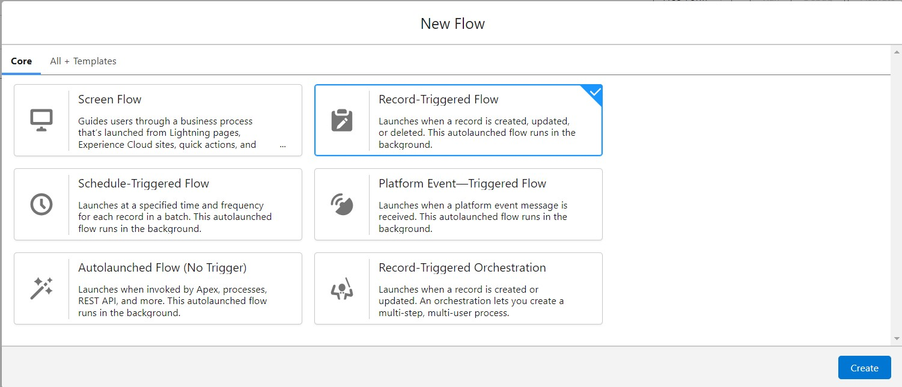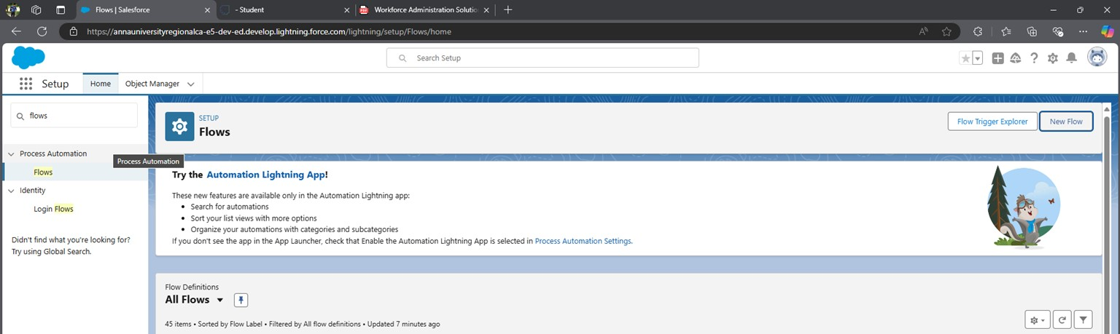

1. In Trigger the flow when Select A record is created
2. Select Condition required All Conditions are met (AND)
3. Select Field - GST_No__c, Operator - Is Null, Value - True.
4. Optimize the Flow for: Actions and Related Records

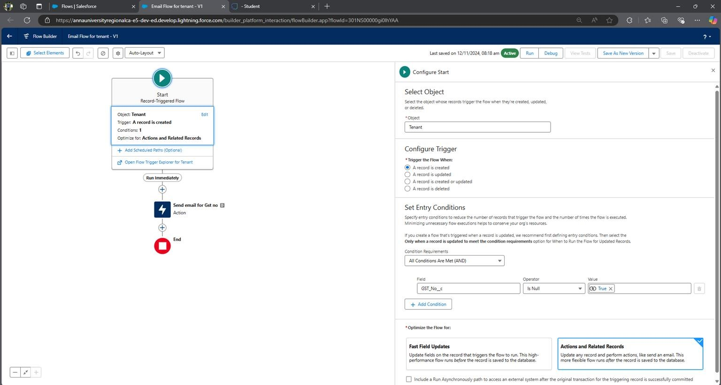

1. Add Element and choose ACTION in the search bar Search Send Email.
2. Label Name - Send email for GST no, Description - This email is to alert the tenant that he or she has not submitted the GST NO yet.

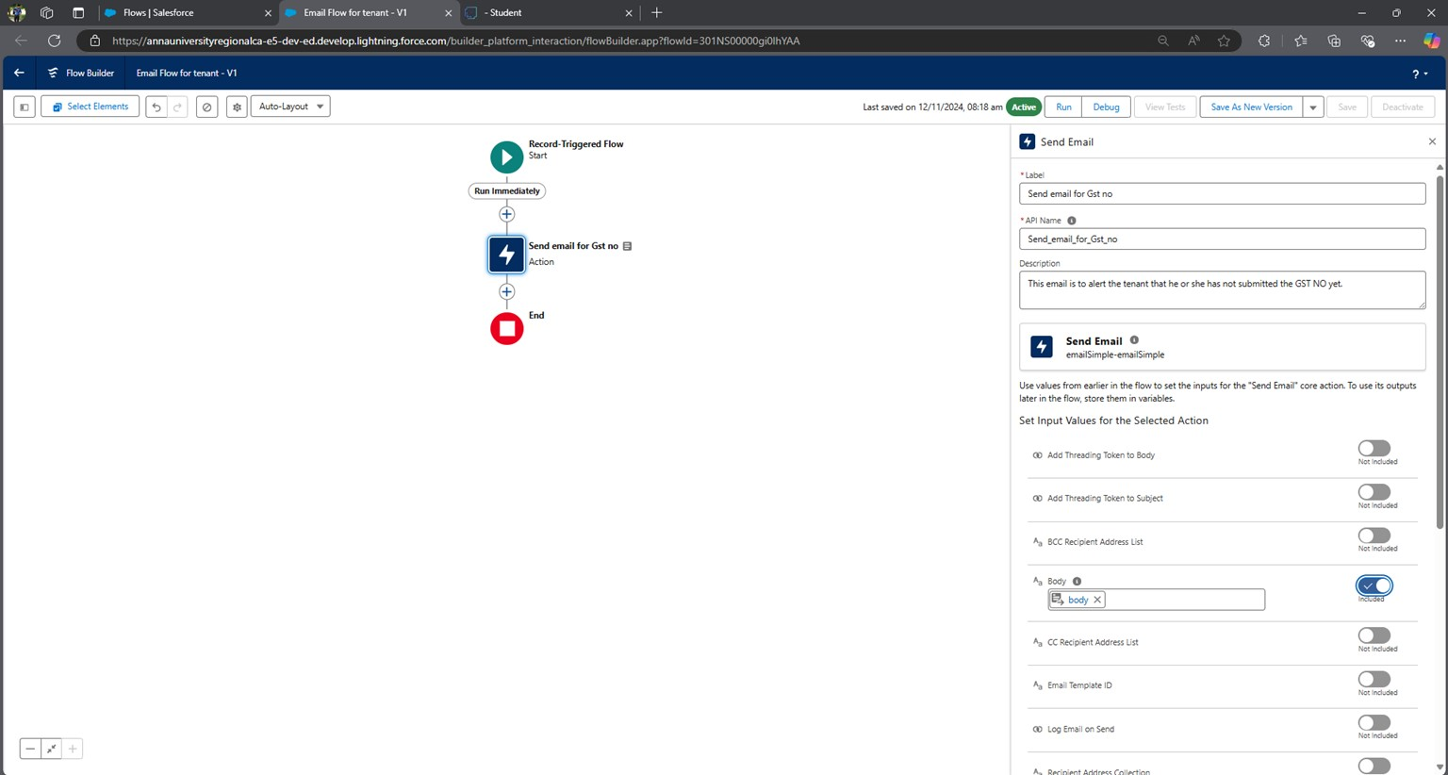

1. Include Body And Create a Resource - Text Template As below-
2. Include Recipient ID and from the profile select tenant Email ID.

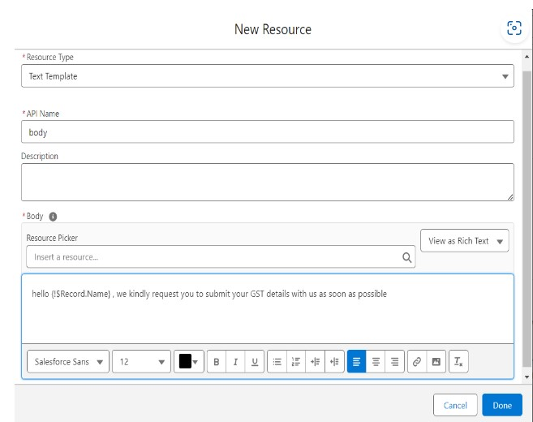

1. Include Subject and enter - Regarding your GST Details

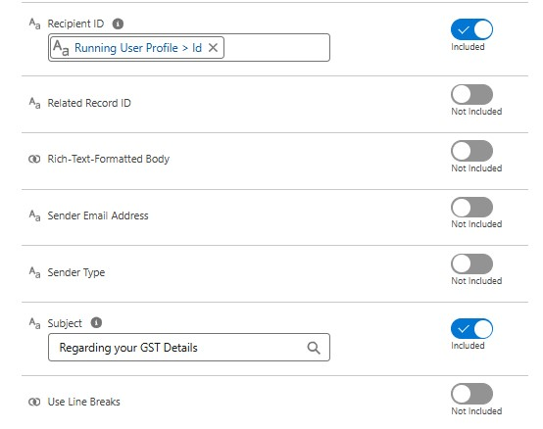

1. Click on Save and Name the Flow as Email Flow for the tenant and Save.
2. Activate the flow.

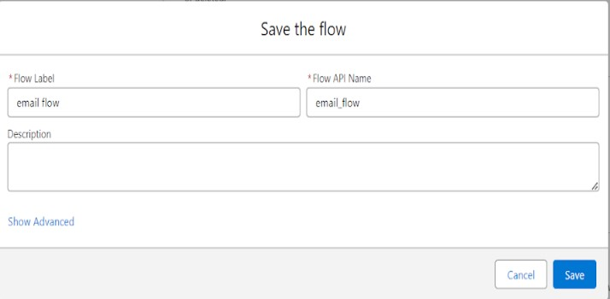

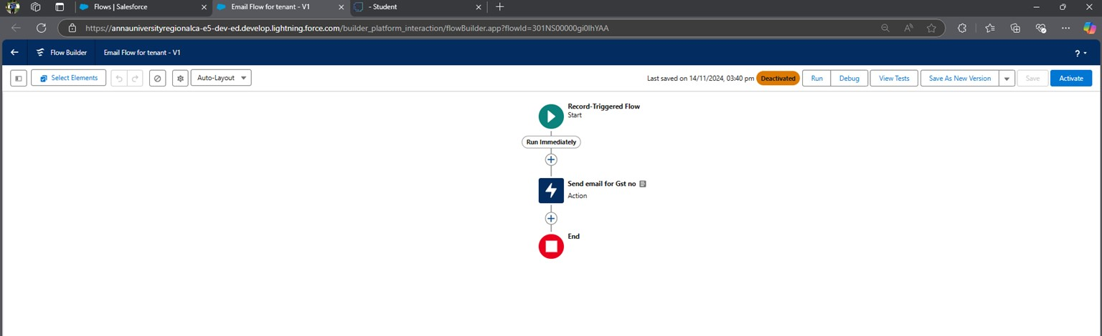

## Activity 2: Create a Schedule Flow on Lease Management Object

If the End Date is within the Next 1 year create a task to the Lease tracking weekly on every Monday.

1. To create a flow click on setup ==> Flow ==> Click on New Flow==> Select ScheduleTriggered Flow

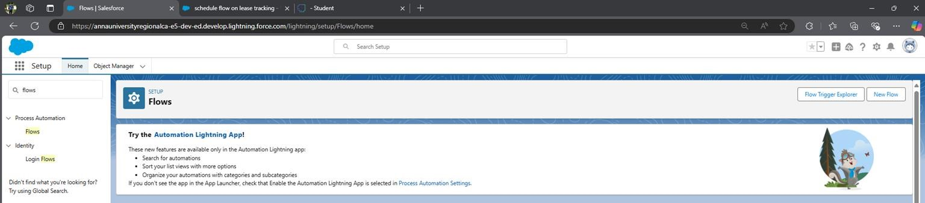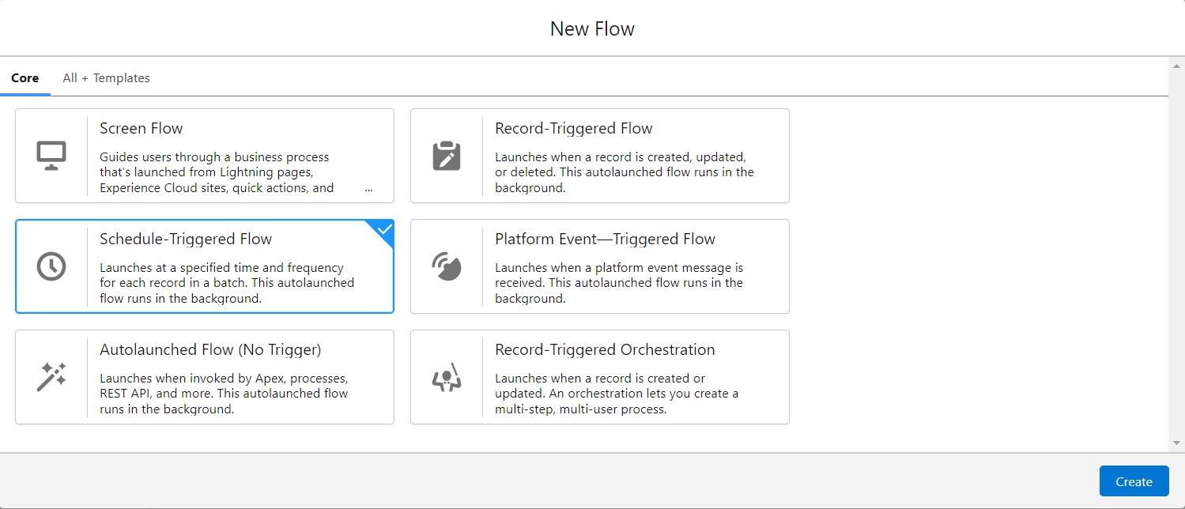

1. Set the Schedule Date - Any Monday, Time - 11.30, Frequency - Weekly.

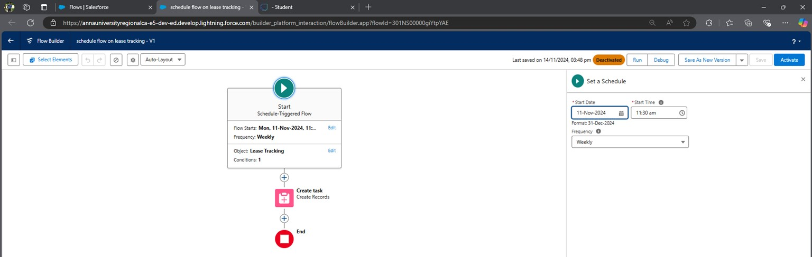

1. Choose Object as Lease Tracking, Condition Requirements - All Conditions are met(AND) 4. Enter field as End_Date_of_Possession__c

5.

Operator

-

Less than & Value

-

1

/

1/2024

6.

Create a Record and give label as Create task

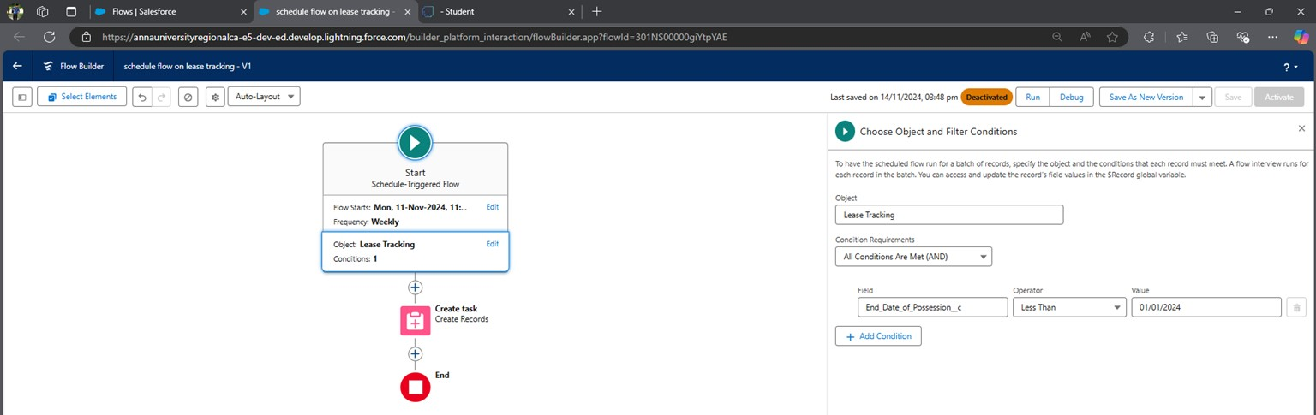

1. How many Records to create - one
2. How to Set the Record Fields - Use Separate Values
3. object - Task
4. Select the field and map them as below: -
5. Subject of the Task - your possession is going to end soon. Please Contact with Manager to renew your Possession or to End the contract.

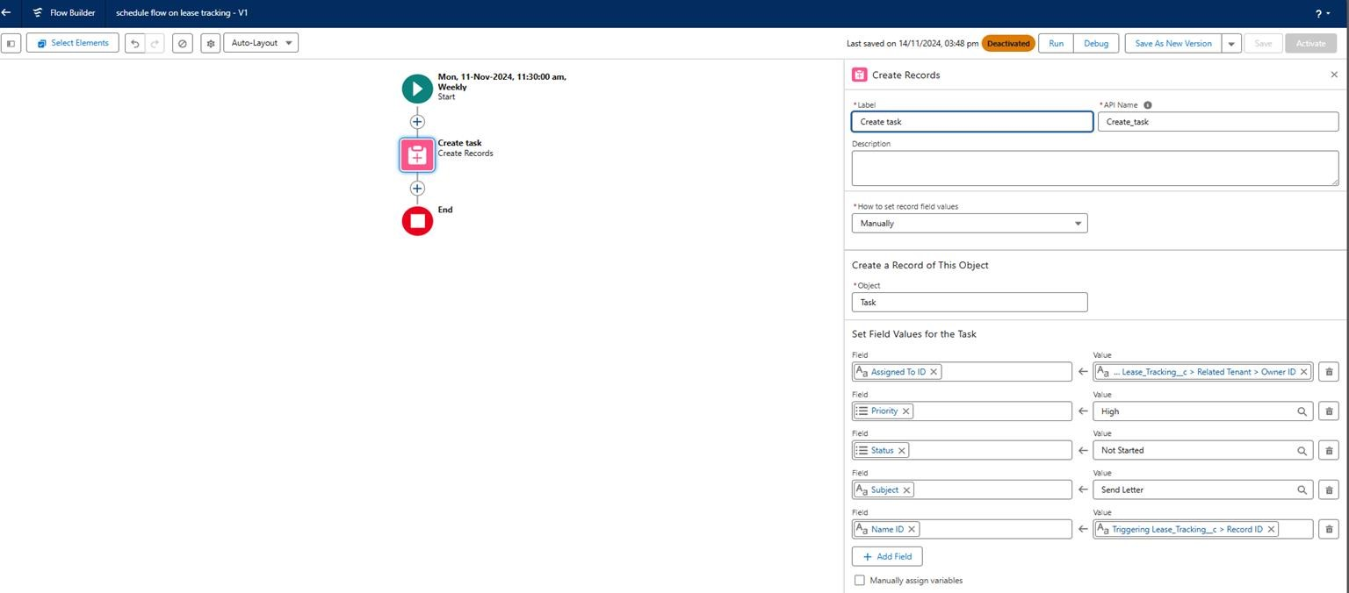

1. Save the flow and label it as ‘ schedule flow on lease tracking’ 13. Activate the flow.

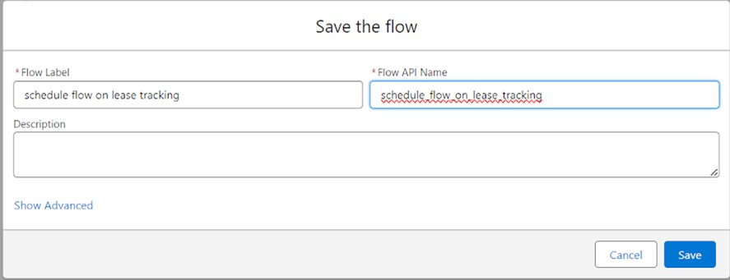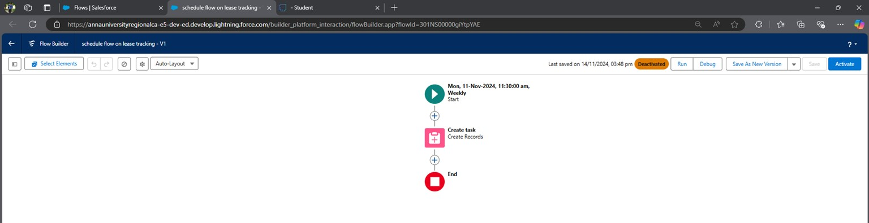

# Milestone 8 - Apex Triggers

**Apex Triggers**

A trigger is a set of Apex code that runs before or after DML(Data Manipulation Language) events.

A DML event could be a variety of data processing tasks that include the standard insert, update, and delete commands.

With Apex triggers, you can automate tasks that would otherwise be nearly impossible to accomplish using only the Salesforce user interface. Triggers enable you to create custom scripts that you can implement according to your needs, and the only limitation is your coding skills.

**There are two Salesforce Apex trigger types:**

Before triggers. These are helpful in cases that require a validation process before accepting a change. They run before any database changes. After triggers. These are helpful in cases where you need to modify your database records and when the necessary value is stored in other records. They run after any database changes. Both types will help you perform custom tasks and manage records effectively. They can help you perform bulk actions as they can handle several records simultaneously.

**How to create a new trigger :**

1. While still in the trailhead account, navigate to the gear icon in the top right corner.
2. Click on the developer console and you will be navigated to a new console window.
3. Click on the File menu in the toolbar, and click on the new Tigger.

Enter the trigger name and the object to be triggered.

**Use Case:**

In Salesforce, Apex Triggers are powerful tools used to perform custom actions before or after specific database events, such as insertions, updates, or deletions on Salesforce objects. For instance, they can enforce business logic by automatically verifying data integrity and ensuring that no incomplete or incorrect records are saved in the system. Triggers can also automate processes such as creating related records; for example, when an Opportunity is created, a Trigger could automatically create related Task records, reminding team members to follow up. Additionally, Triggers help in maintaining data consistency across objects, such as updating parent Account information whenever a change is made to one of its child Contacts. This automation significantly enhances operational efficiency, reducing the need for manual intervention and helping teams to focus on strategic tasks.

**Activity 1: Write an Apex Trigger to send an email if the tenant has not paid 50 Percent of Total Rent.**

1. Click on the gear icon and click on the developer console.

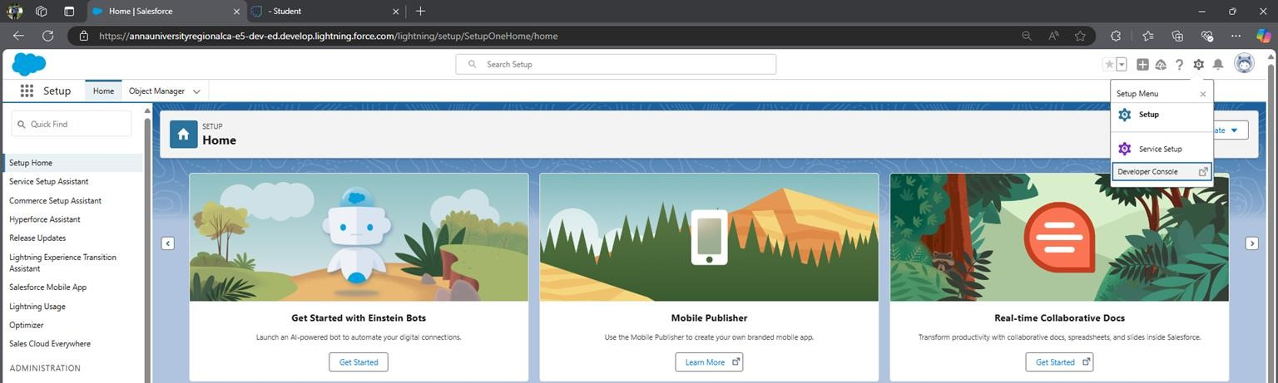

1. Click on the file and select New Apex Trigger

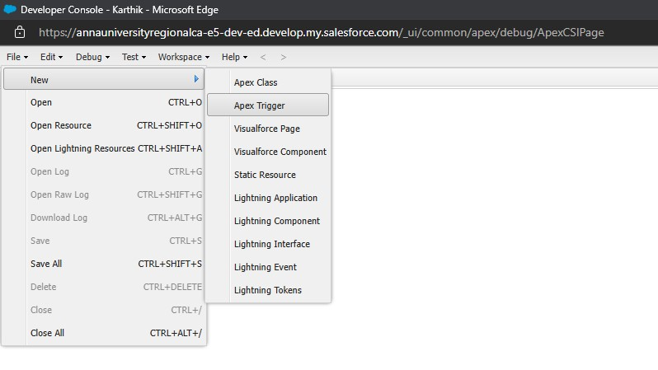

1. Name- leasetrackingtrigger, Object —> Lease_Tracking__c

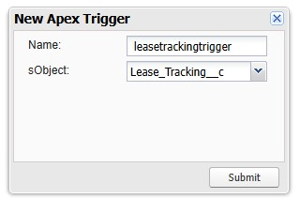

1. Use Event - After Insert and After Update and Use Trigger Context Variables as IsAfter and IsUpdate.

**Trigger: -**

**CODE SNIPPET :**

trigger leasetrackingtrigger on Lease_Tracking__c (After insert, After update)

{ if(Trigger.isAfter && Trigger.IsUpdate)

{

LeaseTrackingTriggerHandler.method1(trigger.old);

}

}

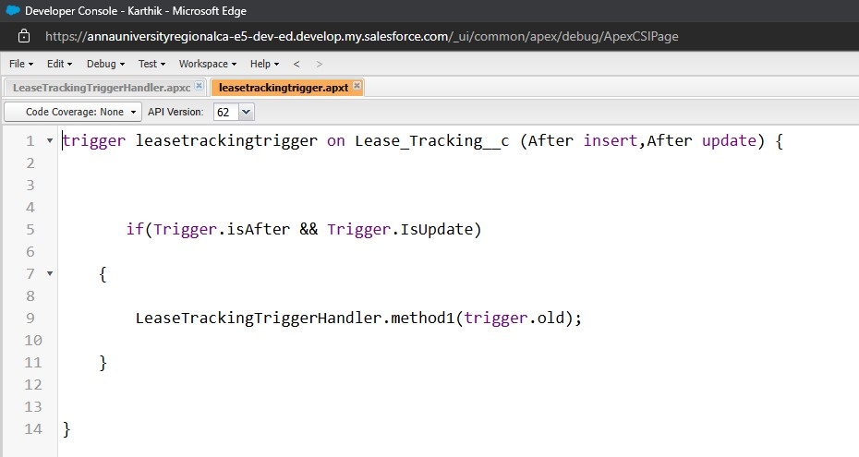

**Trigger Handler: -**

1. Create an apex class and Name it LeaseTrackingTriggerHandler

**CODE SNIPPET: -**

public class LeaseTrackingTriggerHandler

{ public static void method1(List<Lease_Tracking__c> lt1)

{

for(Lease_Tracking__c lt2: lt1 )

{

if(lt2.Amount_to_be_paid__c > (lt2.Total_rent_Yearly__c)/2)

{

Messaging.SingleEmailMessage M = New Messaging.SingleEmailMessage();

List<String> ToADD = New List<String>{lt2.Email_id__c}

M.setToAddresses(ToADD);

M.setSubject('Regarding the Pending Rent');

M.setPlainTextBody('Hello, This is an Reminder for you to complete your due rent by the end this month, your due rent thatneeds to be paid is' +lt2.Amount_to_be_paid__c);

List<Messaging.Email> AB = New List<Messaging.Email>{};

AB.add(M);

Messaging.sendEmail(AB);

}

}

}

}

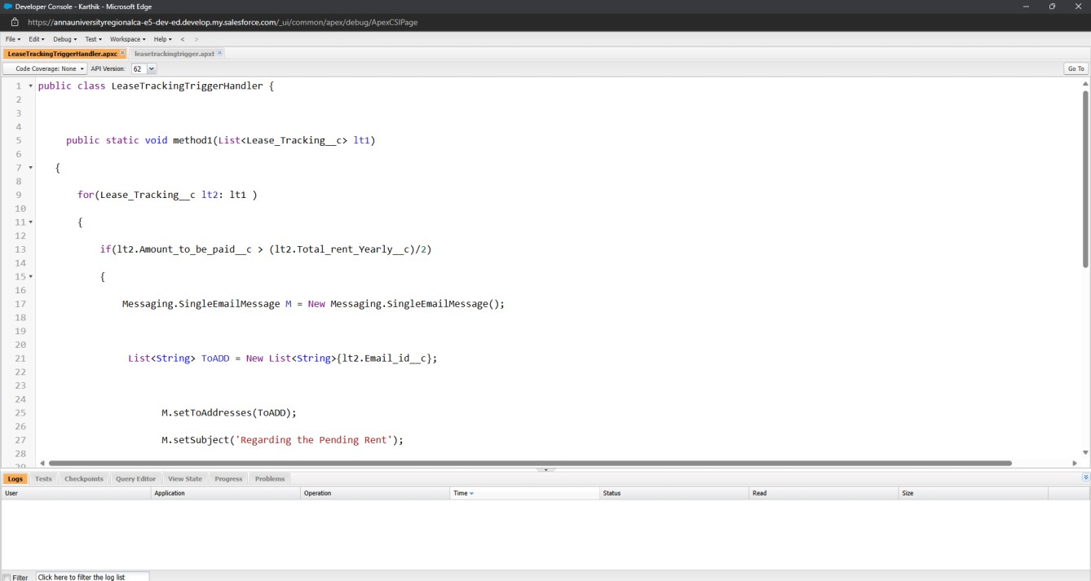

**Activity 2: Write an Apex Trigger on Tenant Object to Show an error if the pan card is invalid.**

1. Click on the gear icon and click on the developer console.
2. Click on the file and select New Apex Trigger

3.

Name

-

TenantTrigger, Object

-

Tenant



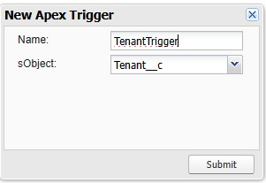

4. Use Events - Before insert and Trigger context Variable - IsBefore

**Trigger: -**

**CODE SNIPPET: -**

trigger TenantTrigger on Tenant__c (before insert)

{ if(Trigger.isBefore)

{

TenantTriggerhandler.method1(Trigger.New);

}

}

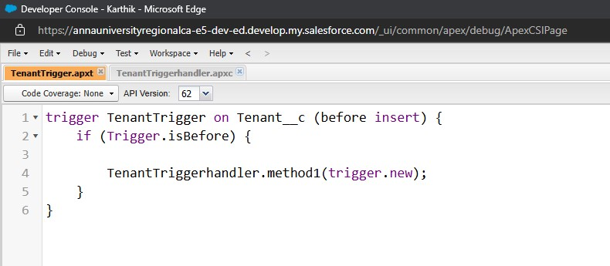

**Trigger Handler: -**

1. Create an apex class and Name it TenantTriggerhandler

**CODE SNIPPET: -**

public class TenantTriggerhandler

{ public static void method1(List<Tenant__c> te)

{

for(Tenant__c tenant : te)

{

if(tenant.Pan_Card_no__c.length() > 10)

{

tenant.addError('This Pan Card number is invalid, Please Enter Valid Pan Card number');

}

}

}

}

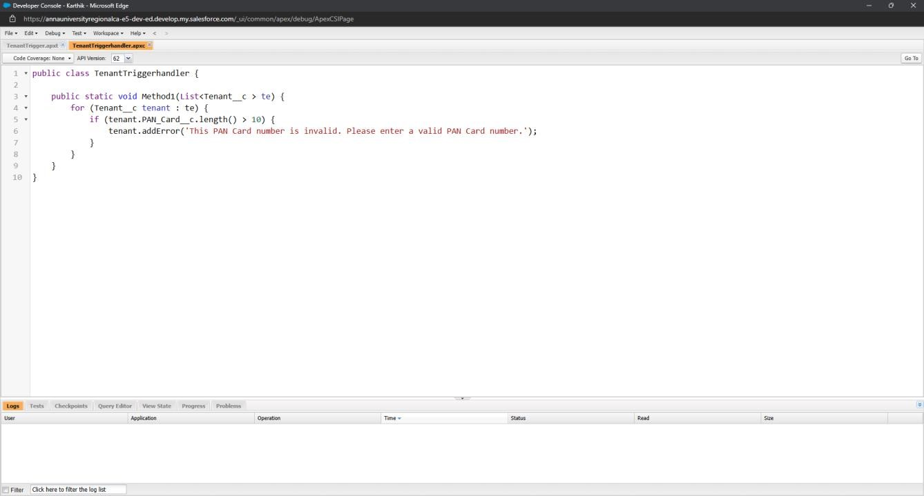

# Milestone 9 - Asynchronous Apex

Asynchronous Apex in Salesforce refers to a programming paradigm where code execution is detached from the immediate context and occurs independently, typically in the background. This approach is designed to handle long-running processes, heavy computations, or tasks that should not block user interactions.

Asynchronous Apex in Salesforce allows developers to perform operations that run in the background without blocking the user interface or delaying immediate actions. This type of processing is essential for handling large data volumes and time-consuming tasks, like making external web service calls, processing batches of records, or executing complex calculations. A common use case for Asynchronous Apex is data processing, where a batch job can update thousands of records without hitting governor limits, ensuring that Salesforce’s resources are efficiently managed. Another use case involves scheduling tasks, such as nightly updates or reporting, where the job can be executed outside of peak hours, reducing the impact on system performance. By using Asynchronous Apex, organizations can improve the performance of their Salesforce org, maintaining responsiveness for users while handling critical background tasks.

**Use Case:**

Asynchronous Apex in Salesforce is used to handle long-running or complex operations that don’t need to finish immediately, allowing the system to manage resources efficiently. For example, it’s ideal for processing large data sets, such as updating thousands of records in the background without impacting the user experience or hitting governor limits. Asynchronous Apex is also useful for integrating with external systems; it can make web service callouts to other platforms and handle responses later, without holding up the main process. In scenarios like scheduled reports, Asynchronous Apex enables automated, time-based actions, such as sending daily summaries of account activities without user intervention. This functionality allows Salesforce to scale operations, maintain system performance, and ensure that heavy tasks are completed in a timely manner without burdening the user interface.

**Activity 1: Schedule Apex**

Delete the Tenant Records Monthly whose Status Of Possession is closed. 1. Create a class with name tenantschedulable

1. Give extension Schedulable to the class.
2. Open the Anonymous Window.

4.

Schedule the class

-

tenantschedulable a = new tenantschedulable();

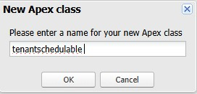

string cron = '0 0 0 1 * ? * ';

system.schedule('Delete the records monthly', cron, a);

**CODE SNIPPET: -**

public class tenantschedulable implements Schedulable

{ public void execute(Schedulablecontext sc)

{

list<Tenant__c> ten = [SELECT Id, Status_of_Possession__c FROM Tenant__c ]; list<Tenant__c> tenantstodelete = New List<Tenant__c>();

for(Tenant__c te: ten)

{

if(te.Status_of_Possession__c == 'Closed')

{ tenantstodelete.add(te);

}

}

Delete tenantstodelete;

}

}

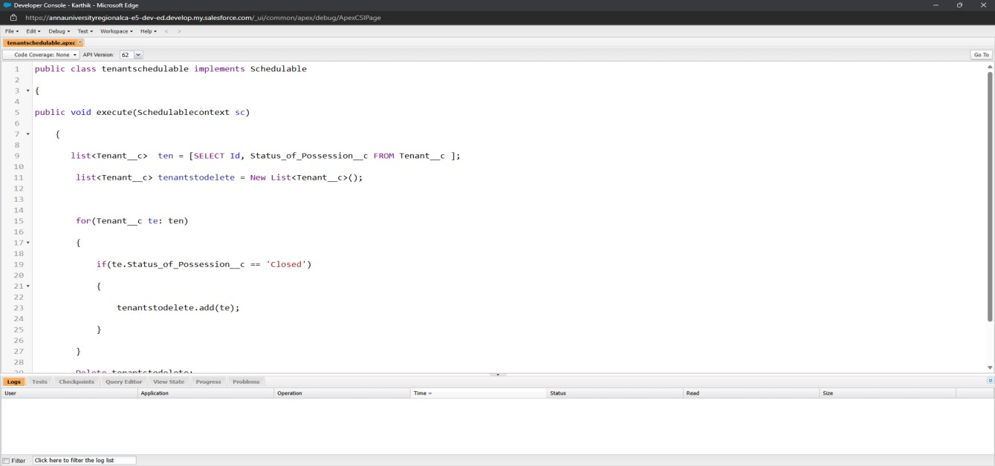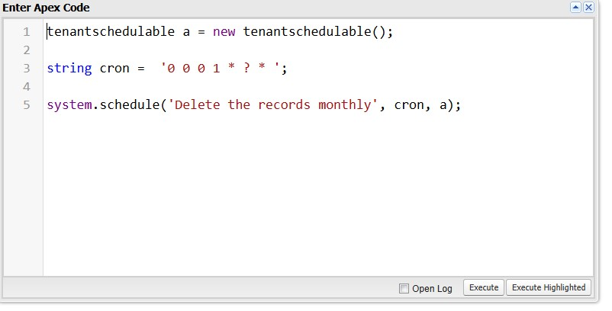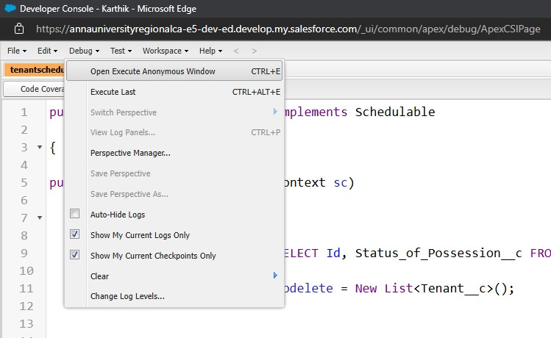

# Milestone 10 - Create Reports And Dashboards

Salesforce Reports and Dashboards are powerful tools that empower users to visualize and analyze data within the Salesforce platform. They play a crucial role in providing insights, monitoring performance, and making informed business decisions.

**Reports:**

Reports give you access to your Salesforce data. You can examine your Salesforce data in almost infinite combinations, display it in easy-to-understand formats, and share the resulting insights with others. Before building, reading, and sharing reports, review these reporting basics.

**Types of Reports in Salesforce**

1. Tabular
2. Summary
3. Matrix
4. Joined Reports

**Use Case:**

The CEO of an organization wants to have brief data on employees working, project intake, project progress, Assets assigned, and the conditions of the Assets assigned. So he can have a clear picture of his organization and be able to make any decisions required based on this data. So he calls you on this task and wants you to represent the data appropriately.

**Dashboards:**

Dashboards help you visually understand changing business conditions so you can make decisions based on the real-time data you’ve gathered with reports. Use dashboards to help users identify trends, sort out quantities, and measure the impact of their activities. Before building, reading, and sharing dashboards, review these dashboard basics.

**Use Case:**

As an Admin for the organization, you keep pushing yourself to reach out the business requirements to take the organization to peak heights and all your superiors are very much impressed with your efforts and work dedication. In addition with reports, you make an ease for the CEO to view the reports with data visualization. So he doesn't have to search for the data he wants during the meetings.

**Activity 1: Create a Report of lease Management Records**

The Manager needs a report that shows the tenant and their joining date and their Remaining payment details also group this by date of Registration, and make a bucket list of the remaining amount as greater than 1000000 red, less than 1000, and greater than 500000 as blue and less than equal to 500000 as yellow.

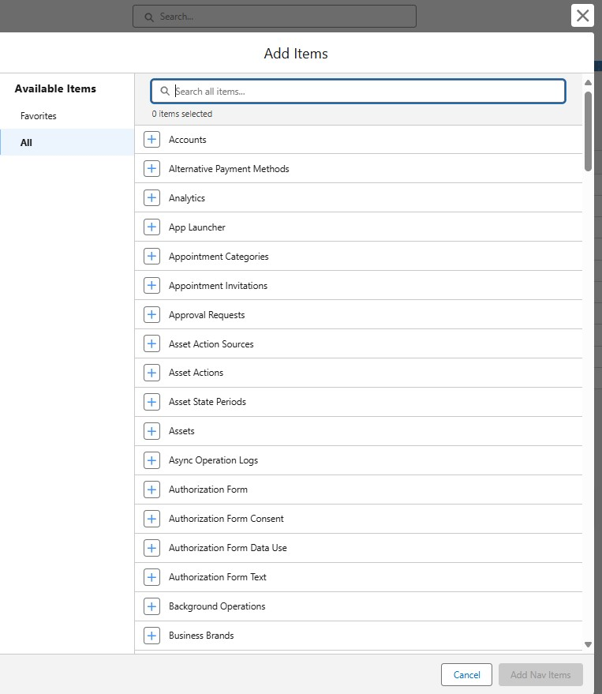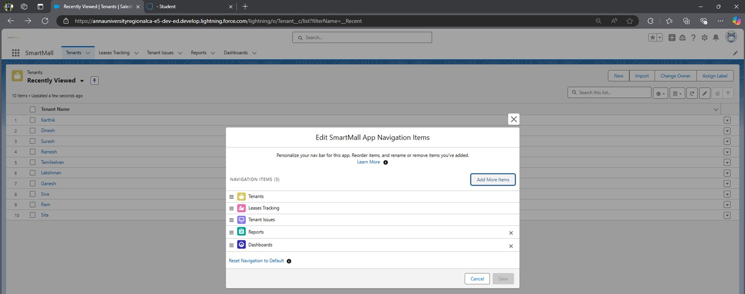

1. Create a new Folder and name it as MallReports

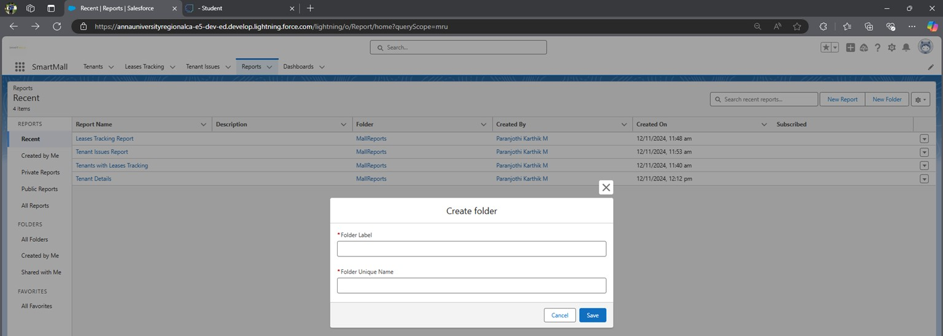

1. Click On new report ==> Select object Activities with LeaseTracking ==> Click on start report
2. Click on the Amount to be paid column click on bucket this list and name it as the Remaining amount

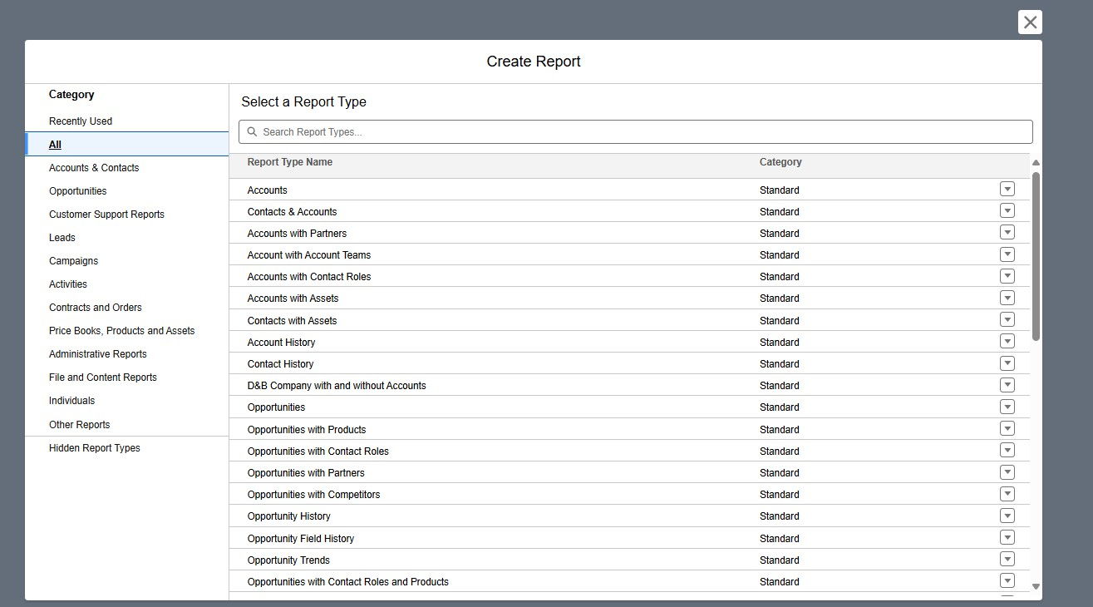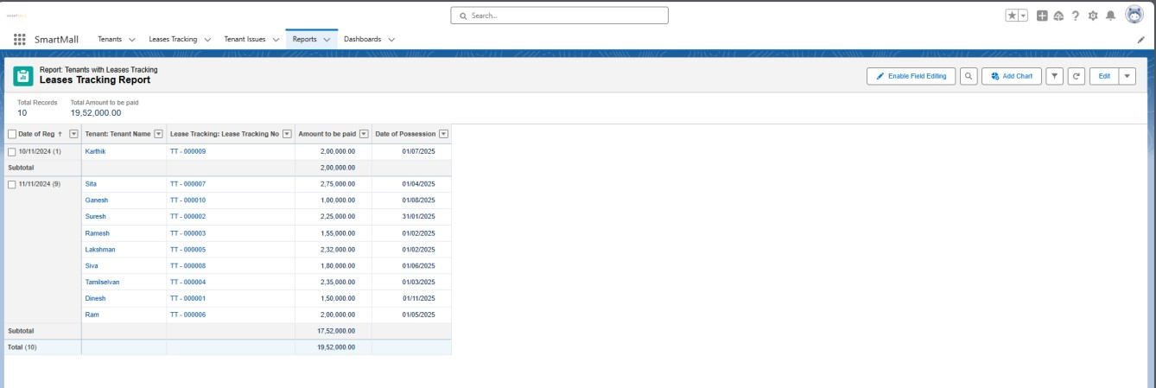

1. Save the report named as lease report and Save it in MallReports.

**Activity 2: Create a Report on Tenant issue Records**

Now the manager is asking for a report on issues that have not been contacted or opened yet and have a high priority which is directly encountered by Phone and Mail and the date of issue is from the last 7 days.



1. Click On new report ==> Select object Activities with Tenant issue==> Click on start report
2. Click on save, enter Name - Issue Report

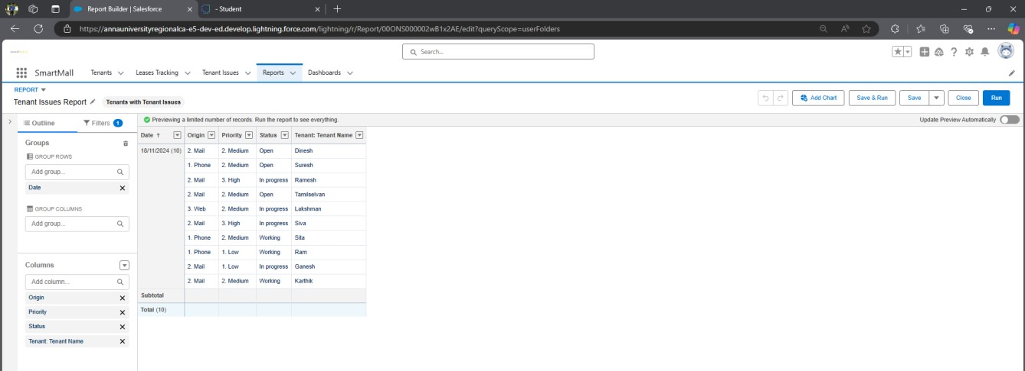

1. Choose the folder Mall Reports and save.

**Activity 3: Create a Report on Tenant Records**

Now, The Manager wants a Report that shows all the pending possessions and also shows the tenant’s Pan Card no and GST NO and group date of reg by column and row by Status of Possession.

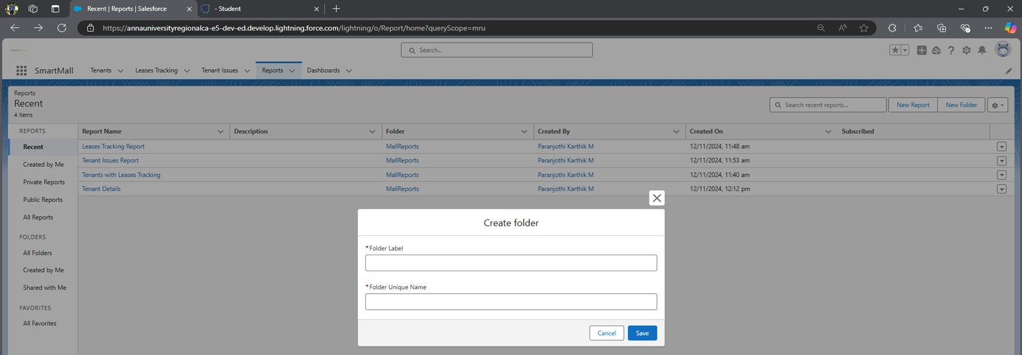

1. Click On new report ==> Select object Tenants ==> Click on start report
2. Choose the folder Mall Reports.
3. Save the report and Name it Tenant Details.

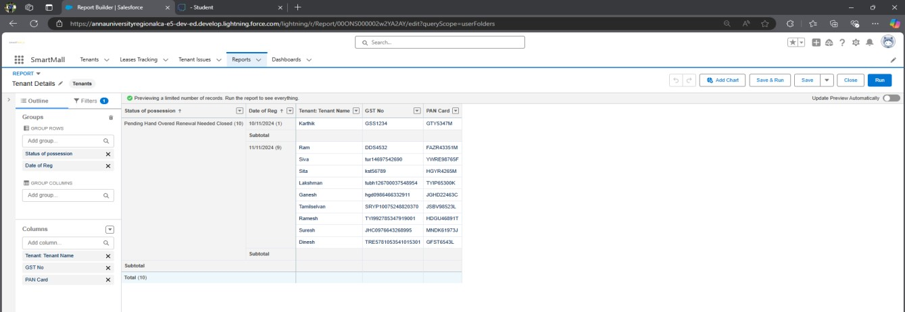

**Activity 4: Create a Dashboard**

Very Good, You have created multiple reports but now for better convenience, the owner wants a Dashboard that shows the data of these reports, So Create a Dashboard and follow the instructions below -

1. To Create a Dashboard first create a folder to store the dashboard and save it as Mall Dashboard.

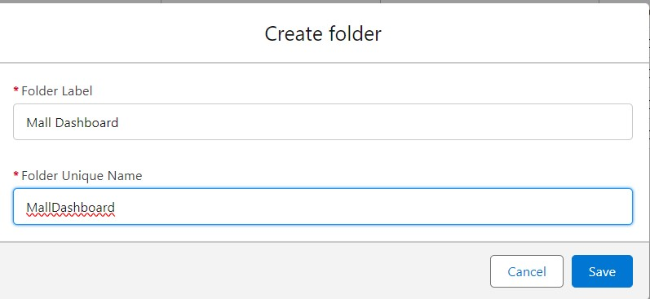

1. Now click on New Dashboard
2. Enter Name - December Dashboard, select the Mall Dashboard folder, and click on Create

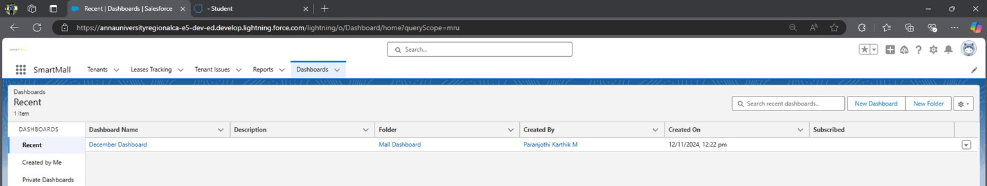

1. Click on + Component and Select Tenant Details, Display as Horizontal Bar Chart, Dimensions - Height * width = 10*12.
2. Click on + Component and Select Issue Report, Display as Lightning Table, Dimensions - Height * width = 8*6.
3. Click on + Component and Select lease report, Display as Lightning Table,

Dimensions - Height * width = 8*6 7) Click on Save and Done.

